6COSC023W – Final Project Report



Student: Wallyson Alves Da Silva

(w1826139)

Supervisor: Francesco Tusa

School of Computer Science & Engineering

University of Westminster

Date

# Document Scope

The purpose of this document is to describe and reflect on the processes that took place in developing the Final Project. Discuss any ethical issues associated with your project and describe the methodology that was adopted to develop its design, implementation and testing.

All chapter word counts in this document are approximate and are not intended to be prescriptive.

*All sections in orange (like this one) must be deleted and removed before submitting the report.*

# Declaration

This report has been prepared based on my own work. Where other published and unpublished source materials have been used, these have been acknowledged in references.

Word Count:

Student Name:

Date of Submission:

*This is an important section!*

*Add the updated word count (do not count words in the Acknowledgments, Table of Contents, Table of Figures, Table of Tables, References, Bibliography and Appendix). Add your name and the date of submission.*

# Abstract

*500 words*

*Summarise here the problem statement and the project aim(s). Provide a brief description of the methodology followed, the main results, your conclusions, and observations.*

Problem Statement

In present-day society, the rapid pace of life combined with demanding work schedules frequently results in a lesser connection between parents and their kids. Notably, parents often endure extensive work hours or face lengthy commutes, considerably reducing the duration and quality of interactions with their children. This reduction in parental engagement can significantly impair both the emotional and cognitive development of children. Mao, Zang, and Zhang (2020) provide a comprehensive analysis of this phenomenon in their study on the effects of parental absence on child development within the Chinese context.

This project was inspired by an initial suggestion from a friend who has recently experienced becoming a father. This friend raised the need for a platform where parents can record messages or bedtime stories for children to play. This would allow his kids, and others like them, to listen to their parents’ voices and hear their stories at any time, even when the parents travel abroad or away from home for extended periods.

Project Objective

The primary goal of this project is to develop "HiKiddo", an innovative mobile application designed to address the issues arising from a physical disconnection between parents and children. The app aims to strengthen familial ties by using modern technological innovations to enhance emotional bonds and support the developmental needs of children through interactive and meaningful engagements.

Principal Outcomes

The "HiKiddo" application is envisioned as a space where family members can collectively participate by adding photos and videos to a shared memory board, creating meaningful voice recordings to be shared, tracking each other's location, and completing the weekly challenges, earning a reward based on points. The project will also involve conducting background research and designing and developing the application using Flutter and Firebase.

This research is designed to comprehensively assess the benefits and challenges associated with developing this project, as well as to evaluate existing tools and platforms that could be utilised. Such a detailed investigation will ensure that the platform is user-friendly, efficient, and easy to navigate. Moreover, the project will include a review phase to reflect on the outcomes and identify potential areas for improvement.

Through this project, I aim to learn the Flutter framework and Dart language, Firebase, and Google Maps Platform and expand my Mobile Full Stack developer skills. By the end of this project, my goal is to deliver a fully operational app that bridges the physical disconnection gap between parents and children, fostering significant interactions and mutual awareness that contribute to family development.

Conclusions and Observations

The "HiKiddo" application is not intended to substitute direct personal interactions but rather to complement them by enhancing familial relationships and supporting pivotal developmental milestones in the lives of children. By concentrating on user-friendly access, emotional bonding, memory conservation, and educational tasks, the application aims to alleviate the adverse effects of parental absence and build family well-being. Ultimately, the "HiKiddo" app endeavours to address the contemporary challenges of familial connectivity by offering a robust platform that aids families in nurturing stronger bonds, irrespective of geographical distances.

# Acknowledgements

*Thank those who helped you build your project and supported you during its development if you wish to hear*.

As I approach the conclusion of my academic journey, I am filled with immense gratitude and a profound sense of achievement. This milestone could not have been reached without the unwavering support and encouragement of many cherished individuals in my life.

First and foremost, I must express my deepest thanks to my fiancée, Catarina Vieira. Her belief in my potential motivated my decision to pursue higher education; without her, I would not have embarked on this incredible journey. Catarina has been my pillar of strength and support throughout these three years, playing a crucial role in shaping the idea behind this project and in the design process of the "HiKiddo" app. Her presence has been a constant source of comfort and motivation. There are no words sufficient to express how grateful I am to have her in my life.

I would also like to extend my sincere gratitude to my supervisor, whose guidance and insights have been crucial. His mentorship has not only helped refine my skills but also enriched my approach to research and development.

Additionally, I owe a great deal of thanks to my colleagues Mohammed Mohammed, Mubashar Khan, and Diogo Sousa. Their constructive feedback, stimulating discussions, and exchange of ideas have significantly contributed to the success of this project.

Each of these individuals has had a profound impact on my personal and professional growth, and I am eternally grateful for their contributions. Thank you for being part of my journey – your support has made all the difference.

# Table of contents

Document Scope 2

Declaration 3

Abstract 4

Acknowledgements 5

Table of contents 6

List of figures 7

List of tables 8

1. Introduction 9

1.1 Problem statement 9

1.2 Aims and Objectives 9

2. Background 10

2.1 Literature survey 10

2.2 Review of projects / applications 10

2.3 Review of tools frameworks and techniques 10

3. Legal, social and ethical issues 11

4. Methodology 12

5. Design 13

6. Tools and implementation 14

6.1 Tools 14

6.2 Implementation 14

7. Testing 15

7.1 Test coverage 15

7.2 Test methodology 15

8. Conclusions and reflections 16

9. References 17

10. Bibliography 18

Appendix I 19

# List of figures

*Provide a list of figures, linking figure numbers to page numbers. If you can, hyperlink the page numbers/figures*.

Figure 1. Add a caption explaining the image here. 9

# List of tables

*Provide a list of tables (if any), linking table numbers to page numbers. If you can, hyperlink the page numbers/tables*.

Table 1. Add caption here. 12

# 1. Introduction

*Introduce the project, include the problem statement, project aim(s) and objectives*.

## 1.1 Problem statement

*500 words*

*Give some background on the problem you intend to solve and the need for the software/application. Use references to support your statements, when possible, illustrations, diagrams, and figures, if needed*.

In our fast-paced world, the rhythm of life has picked up so much that it often pulls families apart, especially straining the ties between parents and their kids. Today's jobs demand long hours, frequent trips away from home, and sometimes even moving to new places, all of which can cut down on the precious time families spend together. This lack of physical and emotional closeness can really weaken family bonds.

Studies like the one by Mao, Zang, and Zhang (2020) in their paper "The Effects of Parental Absence on Children Development: Evidence from Left-Behind in China" show the tough impacts this separation can have. Their research points out that kids who don't see their parents enough might develop more slowly in terms of their thinking abilities and emotional health. This can lead to worse grades in school and low self-confidence, problems that might follow them into their adult lives and affect their careers and personal relationships.

However, with almost everyone having smartphones and access to the internet these days, we have a big chance to use technology to soften some of these negative effects. The "HiKiddo" app is a creative solution designed to close the emotional distance between parents and their children. It offers a way for family members, even if they're far apart, to connect deeply and meaningfully.

The need for an app like "HiKiddo" becomes obvious when we look at how modern family life is shaped and the pressures that come from today's work demands. By offering a way to keep and boost the emotional ties between parents and children, "HiKiddo" seeks to enhance the well-being of families who are trying to cope with being apart physically.

In conclusion, "HiKiddo" aims to meet a vital need for a technological response to the increasing issue of family disconnection in today's digital world. With its features that encourage people to share more through a common space using photos and video and a weekly challenges task that can be used for educational purposes, the app not only helps in the development of children who may not always be physically close to their parents but also reinforces the family ties crucial for a nurtur emotional environment.

## 1.2 Aims and Objectives

*300 words*

*The aim(s) describe, in a few sentences, the overarching purpose(s)/intention(s) of the software/application. What is the point of developing the software/application, what you wish to achieve?*

*Objectives describe with some detail the individual steps you will take to fulfil the project aim(s)*.

Aim

The primary goal of the "HiKiddo" mobile application is to mitigate the emotional and developmental challenges caused by the physical separation between parents and their children, often a result of modern employment demands. Utilising advanced mobile technology, the app strives to improve emotional ties within families, ensuring that children feel connected to their parents even when they are not together physically. The ultimate objective is to cultivate stronger family relationships and support the developmental needs of children through engaging in digital interactions.

Additionally, I aim to create a simple and enjoyable mobile application that is accessible to users of all ages. With "HiKiddo," parents will be able to foster greater awareness of their children's development and the critical importance of parental connection. The app will include features for recording and saving both images and audio, which will help create lasting memories and reinforce familial bonds.

Objectives

To fulfil this aim, the development of "HiKiddo" will follow several targeted objectives:

**Develop an Intuitive User Interface:** Craft a user-friendly interface that both children and adults can easily navigate. This will include straightforward, accessible pathways to the app's various features, like the voice recording system, the memory board, the task and rewards system, and the location map. The interface will also be designed to be visually attractive to draw in users and promote consistent use.

**Implement voice recording Feature:** Incorporate features such as voice recording and real-time sharing to enable parents to leave voice messages, bedtime stories, and personal notes that children can access at any time. This functionality is designed to bridge the emotional gap that physical distance can create.

**Create a Memory Board:** Build a feature that allows families to upload and securely store photos and videos of any important family memento. This feature will serve as a collective space for family members to relive beloved memories and stay connected to their shared past.

**Establish a Task and Rewards System:** Set up a system where parents can assign tasks to their children, including educational assignments or household duties. Children will earn points for completing these tasks, which can then be traded for rewards. This system aims to create a sense of responsibility and motivate children while also making daily tasks more enjoyable while learning soft life skills.

**Ensure Robust Security and Privacy:** Apply strict, safe coding methods to ensure the safety and privacy of all users. Measures will include secure login processes, encrypted data storage, verifying users' access through the system, making sure they only have access to the information related to their family group, and ensuring that families can use the app with confidence.

**Flutter:** Learn the Flutter framework alongside the Dart programming language.

**Design**: Learn about design apps like Figma or web platforms like Canva to create a mock-up/prototype design.

**Database:** Learn about Firebase and how to connect with the application.

**Location services:** Learn how to work and integrate Google Maps Platform into the app.

Through these specific objectives, "HiKiddo" aims to provide a comprehensive tool that not only enhances emotional well-being and strengthens family ties but also supports the cognitive and social development of children in a fun and interactive way.

# 2. Background

*Include a literature survey in the topic, discuss existing similar or relevant applications to yours and the result of a review of tools and techniques that are used to tackle projects similar to yours*.

## 2.1 Literature survey

*800 words*

*Describe initial results of a literature survey on a selected research topic or application area related to your project subject. Use relevant books, published research articles as well as Internet content for the purpose. Make use of in-text references to indicate your sources*.

Understanding the Impact of Parental Work Commitments on Children's Development

In today's busy world, many parents have to work long hours, travel often, or even live temporarily far from home. This can really change the way families interact, especially the crucial bond between parents and children. Let's dive into what this means for kids and how families might cope better with these challenges.

How Parental Work Affects Kids

Imagine a parent missing their child's first steps or other big moments because they're away for work. About 46% of parents worry about this very thing, feeling they might miss important parts of their child's growing up (Employer News, 2020). When parents aren't around as much, kids might feel less connected to them, which can affect how they behave and feel.

Researchers like Elbitar (2020) found that not spending enough face-to-face time with parents can make kids feel emotionally distant. This isn't just about feeling sad or left out—kids might actually act out or have a hard time dealing with their emotions.

Emotional Toll on Families

It's not easy for anyone when families can't be together. Studies suggest that kids might feel more anxious or even depressed when they don't see their parents often (Holleron, 2020). And parents? They feel guilty and stressed about not being there. It's a tough situation that can make everyone feel worse, creating a cycle of stress and upset feelings.

Early research suggests that digital tools can help families stay connected and can really make a difference in kids' emotional and mental well-being. These digital options can give kids the regular contact with their parents they need to grow up happy and healthy.

The concept of "technoference" (McDaniel & Radesky, 2018) highlights how technology can sometimes disrupt personal interactions but also enhance them when used thoughtfully. For family dynamics, apps can create new ways for family members to connect effectively despite physical separation, strengthening family bonds across distances.

Can Technology Help?

So, what can we do about it? Well, technology might help bridge the gap. Apps like "HiKiddo" offer cool features like digital storytelling and interactive tasks that can help parents and kids feel closer, even if they're not physically together. By sharing moments and daily updates, they can keep the parent-child bond strong.

Early Findings and Hopeful Solutions

The "HiKiddo" app is designed with features to enhance family connections:

Interactive Challenges and Rewards - Children can complete parent-set tasks to earn rewards. This encourages not only ongoing communication but also promotes learning and discipline in a fun way.

Voice Recording - Parents can record voice messages or their voices reading a story, creating a sense of presence as they record a story or an important message for their kids, showing that they are there for them and helping to close the emotional gap caused by physical distance.

Memory board - A secure place for families to upload and save photos and videos, accessible anywhere, fostering a shared family album.

Additionally, the "HiKiddo" app includes a location tracking feature that allows family members to see each other’s whereabouts. This function aims to enhance safety and peace of mind by keeping family members connected not just emotionally and digitally but also physically by knowing each other's location.

Creating a family-oriented mobile app comes with significant challenges. Key concerns include ensuring privacy and security due to the sensitive data, like photo uploads and location tracking. Moreover, the app must be accessible to all ages, requiring careful design to make sure it's easy for young children to use. This involves detailed testing and user interface adjustments to accommodate inexperienced users.

In Summary

In conclusion, research shows children's challenges when separated from their parents, but technology like the "HiKiddo" app can bridge the gap, ensuring continuous love and communication. This app not only supports children’s emotional health but also provides parents with the necessary tools to maintain strong connections, irrespective of their busy schedules. By integrating these features effectively, "HiKiddo" has the potential to greatly enhance parental involvement and redefine digital interactions within families, keeping family ties strong, even from afar.

## 2.2 Review of projects / applications

*800 words*

*Describe your background research on existing projects/software/applications, tools/frameworks/methods/algorithms/techniques relevant to your project, their advantages, and disadvantages. Use illustrations, diagrams, screenshots for the purpose.*

*You may produce a Table of Features in this section, comparing the main features of the above projects/software/applications and the one you developed.*

*A comparison table may also be provided to distinguish the key characteristics of features/methods/algorithms/techniques relevant to your project*.

Introduction

Exploring existing applications is crucial in software development, providing developers with essential insights and a deep understanding of the market. Through comprehensive analysis of successful family-oriented applications, developers can identify best practices, discover innovative features, and avoid potential pitfalls. This proactive approach is detailed in the next section, which examines three real-world applications that exemplify these strategies, helping to shape the development of new projects like the "HiKiddo" app.

The concept for the "HiKiddo" app was sparked by both a personal story and a clear need for more family-oriented mobile applications. The development process included a detailed analysis of existing apps such as Remento, Life360, and FamilyAlbum, which vary in their offerings from location tracking to photo sharing. This exploration helped identify key features that could enhance family connectivity. It guided the refinement of "HiKiddo" to ensure it offers unique and valuable functions that are not fully addressed by current market options.

Remento

Remento is an innovative online platform that helps users preserve and share significant memories using media such as photos, videos, and audio clips. As physical albums and journals become less common, Remento offers a digital solution to capture and catalogue personal stories easily.

One standout feature of Remento is its "speech-to-story" function, which turns voice recordings into text. This tool makes it easier to preserve spoken memories as written narratives. Although the platform is user-friendly, its aesthetic, characterised by dark green tones, tends to be more adult-oriented and might not attract a younger audience.

Influence on HiKiddo App Development

Inspired by Remento's capabilities, including a section for photos and videos will be crucial for the HiKiddo mobile app. The "speech-to-story" feature, particularly, has caught my attention as a potential addition to HiKiddo. Implementing a similar feature could enhance the storytelling experience within the app, making it more engaging for users to create and share their narratives. However, introducing this feature is not currently a primary focus for immediate development in HiKiddo but remains a consideration for future updates.

Functionality and Design Considerations:

Functionality: Remento primarily supports the saving and sharing memories through various media, enriching users' storytelling experiences.

Unique Feature: The innovative "speech-to-story" technology transforms voice recordings into text.

Pros: This feature simplifies the process of capturing and sharing stories, making it more accessible to users who prefer text over audio.

Cons: The app's design, with its mature colour palette, may not appeal to all age groups, particularly younger children.

Influence on HiKiddo: The structure of Remento has inspired integrating multimedia memory sections in HiKiddo and highlighted the potential for adopting a similar speech-to-text feature in the future.

This analysis underscores the importance of Remento as a source of inspiration for enhancing the HiKiddo app's capabilities and creating a more interactive and memorable user experience.

Life360

Life360 is distinguished by its strong focus on family safety through its digital and location-based features, making it highly pertinent to developing the HiKiddo app. Notably, Life360 offers advanced features such as real-time location tracking and a unique crash detection system, which are crucial for ensuring the safety of family members.

For HiKiddo, integrating similar location-based functionalities is a priority, allowing parents to monitor their children’s locations to ensure their safety effectively. Additionally, Life360's user-friendly interface and comprehensive tutorial guide offer excellent frameworks for designing an intuitive and straightforward user interface for HiKiddo. The visually appealing design elements like colour schemes and animations used in Life360 are also inspirations for HiKiddo to maintain user engagement and ensure a pleasant user experience.

Functionality and User Interface Design:

Functionality: Life360 has features that prioritise family safety, including real-time location tracking and a sophisticated crash detection system.

Pros: The application is known for its user-friendly interface that includes helpful tutorial guides and its attractive design characterised by vibrant colours and dynamic animations.

Cons: The app's focus is predominantly on safety features, which may come at the expense of fostering everyday family interactions and bonding.

Influence on HiKiddo: Life360 has significantly influenced HiKiddo's user interface design choices. It has guided the inclusion of similar digital location tracking features, which are tailored to enhance family safety within the HiKiddo environment.

This comprehensive evaluation of Life360's capabilities highlights how its features and design can enhance the HiKiddo app. By incorporating Life360's robust safety tools and user-friendly interface into HiKiddo, the app not only aims to ensure child safety but also to offer an engaging and easy-to-navigate experience for all family members.

3. FamilyAlbum

FamilyAlbum, developed by Kenji Kasashara, is a mobile app designed to make it easy for families to organise and share photos and videos from significant events securely. The app emphasises simplicity and security, allowing users to keep cherished family moments safe while sharing them with loved ones.

While FamilyAlbum features a clean and straightforward design, its user interface has some complexities that could be challenging for certain age groups. Introducing a tutorial guide could significantly enhance accessibility, helping users of all ages to navigate and use the app more effectively.

FamilyAlbum's core mission to make the sharing and organizing of family memories straightforward has significantly shaped the HiKiddo app. Drawing inspiration from this, HiKiddo incorporates similar functionalities, allowing users to easily add photos and videos, which ensures that these cherished moments are both secure and readily sharable.

Functionality: FamilyAlbum provides a user-friendly platform for families to store, share, and manage photos and videos, ensuring these memories are kept safe and organized.

Pros: The application offers robust security features that protect personal and sensitive data, making it a trustworthy repository for family memories.

Cons: The interface, while clean, maybe slightly complicated for some users, particularly younger or older family members who are not as tech-savvy; it also lacks features that facilitate interactive engagement.

Influence on HiKiddo: Inspired by FamilyAlbum, the HiKiddo app will feature a "memory board" where users can upload photos and videos or even capture moments in real-time using the camera. This addition aims to enrich the user experience by making the sharing and preservation of family memories more dynamic and interactive.

This analysis highlights the strengths of FamilyAlbum's approach to family memory sharing while identifying areas for enhancement. HiKiddo can build on these insights to offer a more comprehensive and engaging platform that improves family connectivity, addressing the gaps found in FamilyAlbum's current setup.

Comparative Analysis

To better illustrate the distinctions and inspirations drawn from these applications, a Table of Features was created:

This table shows how "HiKiddo" incorporates and expands upon the best features of these apps.

|  |  |  |  |  |
| --- | --- | --- | --- | --- |
| Features | Remento | FamilyAlbum | Life360 | Hikiddo |
| Login/Sign up | Tick with solid fill | Tick with solid fill | Tick with solid fill | Tick with solid fill |
| User Friendly to all ages | Close with solid fill | Close with solid fill | Close with solid fill | Tick with solid fill |
| Join a family group | Close with solid fill | Close with solid fill | Tick with solid fill | Tick with solid fill |
| Add photos and videos in a shared space | Close with solid fill | Close with solid fill | Close with solid fill | Tick with solid fill |
| Shared voice recording | Close with solid fill | Close with solid fill | Close with solid fill | Tick with solid fill |
| Speech-to-text | Tick with solid fill | Close with solid fill | Close with solid fill | Close with solid fill |
| Family comments to photos & videos | Close with solid fill | Tick with solid fill | Close with solid fill | Close with solid fill |
| Generate a compilation of moments with photos and videos | Close with solid fill | Tick with solid fill | Close with solid fill | Close with solid fill |
| Challenges and rewards section shared with the family group | Close with solid fill | Close with solid fill | Close with solid fill | Tick with solid fill |
| Tasks that can be used for educational purpose | Close with solid fill | Close with solid fill | Close with solid fill | Tick with solid fill |
| Share current location | Close with solid fill | Close with solid fill | Tick with solid fill | Tick with solid fill |
| Retrace members location | Close with solid fill | Close with solid fill | Tick with solid fill | Close with solid fill |
| Emergency SOS button | Close with solid fill | Close with solid fill | Tick with solid fill | Close with solid fill |
| Paid subscription needed | Tick with solid fill | Close with solid fill | Tick with solid fill | Close with solid fill |

Advantages and Disadvantages

"HiKiddo" stands out from other apps because it really focuses on helping families stay connected in a fun and safe way. It has featured such the memory board that lets you keep all your special memories in one place, but it's even more than that. The app also motivates family members to keep in touch and do activities together every week, whether through sending little voice recording or completing fun tasks together. Plus, it's designed to be super easy to use, so everyone from kids to grandparents can get the hang of it quickly.

A potential disadvantage could be the complexity of offering multiple features in one app, which might overwhelm new users. However, this is mitigated by the planned tutorial guides and intuitive design inspired by Life360.

Conclusion

The background research into existing family-oriented applications provided crucial insights that shaped the development of "HiKiddo." By analysing the strengths and weaknesses of these apps, "HiKiddo" was designed to offer a comprehensive and engaging platform that not only ensures safety but also promotes active family engagement, filling a unique niche in the app market.

## 2.3 Review of tools, frameworks and techniques

*800 words*

*Describe results of a survey on relevant tools/frameworks that can be used to develop applications such as the one you built for your project, such as programming languages and environments, libraries. List their advantages and disadvantages. Use illustrations, diagrams, screenshots for the purpose*.

Choosing the right tools, frameworks, and techniques is crucial in mobile app development, as these decisions greatly affect how the project turns out in terms of efficiency, quality, upkeep, and how well it can grow in the future.

This section offers a detailed review of the pros and cons of different programming languages and development tools, including Flutter, Kotlin, React Native, Swift, PostgreSQL, Firebase, and MySQL. We will thoroughly explore each technology to highlight its main advantages and limitations, providing clear insights to assist in selecting the best technologies for developing the “HiKiddo” app.

Flutter (Mobile Development Framework by Google)

Flutter is an open-source UI software development kit developed by Google. It allows developers to build high-quality applications for mobile, web, and desktop from a single codebase. As a contemporary toolkit, Flutter enables the creation of visually striking applications that compile directly to native code on various devices and operating systems. Supporting multiple platforms such as Android, iOS, Linux, macOS, and Windows, Flutter offers a flexible and versatile option for developers looking to create cross-platform apps.

Advantages:

1. Single Codebase: Use one codebase for both platforms, making development simpler and cheaper.
2. Hot Reload: See changes instantly without restarting the app, speeding up development.
3. Performance: Compiles into native code for fast, smooth device performance.
4. UI Capabilities: Lots of customisable widgets to create attractive, easy-to-use interfaces.
5. Growing Community: A rapidly expanding community provides great support and resources for developers.

Disadvantages:

1. Large App Size: Flutter can create larger app files, which might slow down download times and use more data, which is not ideal for making lightweight apps.
2. Developing Ecosystem: As a newer technology, Flutter doesn't have as many third-party resources or libraries yet, which might limit your options and extend development time.
3. Learning Curve: Flutter uses Dart, a less common programming language than JavaScript, which might take some time to learn if you're new to it.

React Native

React Native is a free-to-use framework that lets you create cross-platform mobile apps for Android and iOS using JavaScript and React, a JavaScript library for making user interfaces that Facebook and Instagram developed alongside a global community of developers. This framework utilises JSX, which combines JavaScript with HTML-like syntax, to help developers write richer app interfaces and enable smooth cross-platform mobile applications that feel truly native.

Advantages:

1. Declarative Programming Model: Makes code easy to read and debug by clearly showing how data changes, helping you quickly solve problems.
2. Component-Based Architecture: Organizes code into reusable pieces for a cleaner codebase and simpler development, ideal for ongoing projects and future maintenance.
3. Virtual DOM: Speeds up app rendering for a smoother user experience by minimising direct changes to the DOM.
4. Community Support: Offers a strong network with access to numerous resources like libraries and expert advice, which can be incredibly helpful in overcoming challenges and learning new skills.
5. Integration Capabilities: Provides the flexibility to use various libraries and frameworks, enhancing creativity and adaptability in app development.

Disadvantages:

1. Learning Curve: JSX and complex JavaScript concepts might be difficult for beginners, potentially steepening the initial learning phase.
2. Optimisation: Poorly optimised code can slow down the app, necessitating careful coding to ensure smooth performance.
3. Memory Management: Apps with many features may have large file sizes, leading to longer loading times, particularly on slow internet connections.
4. Setup Complexity: Setting up modern development tools can be complex and time-consuming, possibly overwhelming for those new to programming.

Kotlin

Kotlin is a programming language that Google officially endorsed in 2017 as the preferred language for Android app development. It’s open-source and compiles to Java bytecode, allowing it to run on the Java Virtual Machine (JVM). Kotlin integrates functional programming features with object-oriented principles, making it a flexible and modern choice for developers who want to create Android apps or other types of applications that operate on the JVM.

Advantages

1. Full Interoperability with Java: Kotlin is fully compatible with Java, allowing both languages to be used seamlessly in the same project. This helps teams smoothly transition from Java to Kotlin or maintain both on ongoing projects.
2. Concise and Expressive Language: Kotlin reduces unnecessary code, making it clearer and easier to manage. This leads to fewer bugs and easier debugging.
3. Enhanced Type Safety: Kotlin's approach to nullability reduces the risk of null pointer exceptions, a common issue in Java, enhancing application stability.
4. Support for Functional Programming: Kotlin supports functional programming features like lambdas and higher-order functions, enabling cleaner and more expressive code.
5. Advanced Concurrency with Coroutines: Kotlin’s Coroutines simplify handling long-running tasks and asynchronous programming, improving code manageability and performance without blocking the main thread.

Disadvantages

1. Learning Curve: Even though Kotlin works well with Java, Java developers might need time to adjust to the different syntax and advanced features.
2. Tooling Support: Kotlin has good tools, but they may not be as extensive or advanced as Java's due to its longer establishment period. This could make finding specialised tools or troubleshooting more difficult for Kotlin developers.
3. Compilation Time: Kotlin usually has slower compilation times compared to Java, which could be a setback in large projects that need frequent compilation, potentially affecting productivity.
4. Developing Ecosystem: The Kotlin ecosystem is expanding but isn't as developed as Java's. This means there are fewer third-party libraries, and those available might not be as robust, limiting resources for developers.
5. Performance Issues: Kotlin might face performance and compatibility issues, particularly with complex Android features like the Android NDK, which could complicate app optimisation and feature implementation.

Swift

Swift is a programming language developed by Apple that has quickly become a favourite among developers due to its outstanding performance, user-friendly nature, and broad range of powerful features.

Advantages

1. High Performance: Swift is known for its speed and efficiency, significantly outperforming languages like Objective-C and enhancing both app performance and development speed.
2. Enhanced Safety Features: Swift includes advanced safety features that prevent common errors like null pointer dereferencing, reducing crashes and making it a reliable choice for programming.
3. Improved Readability: With a clear and intuitive syntax, Swift is easier to read and maintain than Objective-C, improving productivity and reducing errors.
4. Seamless Compatibility: Swift works well with Objective-C and C, allowing developers to easily merge existing code into new Swift projects without extensive rewrites, speeding up development.
5. Open-Source Nature: As an open-source language, Swift is supported by a global community of developers, ensuring it stays updated and responsive to developer needs.

Disadvantages

1. Learning Curve: Swift might be user-friendly for experienced programmers, but beginners could find its streamlined syntax and structure a bit daunting.
2. Limited Compatibility: Swift doesn’t support older iOS versions, so apps built with it are only functional on newer iOS devices, possibly limiting the user base.
3. Complex IDE Setup: Using Xcode, Swift’s main IDE, can be complicated for newcomers, adding difficulty to the initial setup and learning process.
4. Rapid Updates: Swift frequently updates, which keeps it modern but can create compatibility issues between versions, requiring developers to update their code often.
5. Smaller Community: The Swift community, while active, is smaller than those for more established languages, which can make finding help and resources more challenging.

PostgreSQL

PostgreSQL is a robust open-source relational database management system highly regarded for its stability, functionality, and flexibility. Below are detailed lists of the advantages and disadvantages of using PostgreSQL for database management in various applications.

Advantages

1. Open Source & Cost-Effective: PostgreSQL is free to use, modify, and distribute, providing a budget-friendly option for database management.
2. Advanced SQL & High Extensibility: Supports complex SQL queries, allows custom functions to be added, and supports multiple programming languages, including Python and Perl.
3. ACID Compliance & Robust Security: Offers reliable transaction processing with full ACID compliance and includes strong security measures like encryption and SSL support.
4. Cross-Platform Compatibility & Scalability: Runs on various operating systems like Windows, Linux, and macOS and can scale to handle large data volumes for growing applications.
5. Community Support & Crash Recovery: Benefits from a vibrant community for development support and features effective crash recovery mechanisms to maintain data integrity.

Disadvantages

1. Complexity for Beginners: The extensive features and advanced SQL can be daunting for newcomers.
2. Performance Issues: While fast for many tasks, PostgreSQL may lag in specific operations like bulk data imports.
3. Resource Demands: It can be resource-heavy and need a lot of memory and storage, which might impact performance on limited systems.
4. Migration Challenges: Limited compatibility with other databases can make transferring data complex.
5. User Interface and Maintenance: Lacks a built-in graphical user interface, requiring reliance on third-party tools, and might need more maintenance and configuration effort.

MySQL

Advantages:

1. Cross-Platform Support: MySQL works well across all major operating systems like Linux, Windows, and macOS, offering great flexibility.
2. Cost-Effectiveness: It’s affordable, which makes it an attractive choice for small businesses and independent developers.
3. Security: MySQL secures data with strong encryption, including Secure Sockets Layers (SSL), to safeguard sensitive information.
4. Performance: Designed for high performance, MySQL can manage large data volumes efficiently due to its effective storage engine.
5. Scalability: MySQL scales smoothly to accommodate growing data demands, ideal for expanding applications.

Disadvantages:

1. Functional Limitations: MySQL may not have as many advanced features as other databases like Oracle or SQL Server, which could be a drawback for complex database projects.
2. Support Issues: Although MySQL has a strong community, the absence of official support might be challenging; however, commercial support is available.
3. Data Type Limitations: MySQL offers fewer data types compared to other databases, which could limit its applicability in specialised scenarios.
4. Stability Issues: Some newer versions of MySQL might experience stability issues, depending on the setup and environment.
5. Complex Configuration: Setting up and optimising MySQL can be intricate and might take considerable time, especially for those unfamiliar with the database.

Firebase (Backend Platform by Google)

Advantages:

1. Real-Time Database: Enables instant data sync across users, keeping everyone on the latest update without manual refreshing.
2. Scalability & Ease of Use: Automatically scales to meet app demands and offers simple integration for robust security features.
3. Serverless Hosting: Minimizes server management, allowing developers to focus on app features.
4. Data Insights: Comes with analytics tools that provide insights into user behaviour to help improve the app dynamically.
5. Offline Capabilities: Supports local data storage that automatically syncs when online, enhancing reliability and user experience even offline.

Disadvantages:

1. Simple Query Structure: Lacks support for complex SQL-like queries, potentially limiting advanced data manipulation.
2. Dependency on Google: Heavy reliance on Google’s infrastructure might reduce flexibility in certain use cases.
3. Scalable Costs: Costs may rise with increased usage, potentially becoming expensive for growing applications.
4. JSON Data Storage: JSON is used mainly, which may necessitate changes in data handling and storage strategies.
5. Limited Data Retrieval: Not as capable as traditional SQL databases for specific data retrieval needs, which could be restrictive.

# 3. Legal, social and ethical issues

*300 words*

*Consider any legal, ethical, social, professional and security issues associated with your research and the software/application you are building and/or the data you are collecting/analysing*.

When developing apps like "HiKiddo," it's essential to consider a comprehensive range of factors to ensure the application is legally compliant, ethically sound, and secure. This approach not only safeguards users, especially children but also builds trust and adheres to international standards.

Legal Considerations

"HiKiddo" must adhere to strict legal standards like the GDPR and COPPA, which involve securing explicit parental consent for collecting data from children and using this data strictly for defined purposes. This is crucial for the responsible handling of personal information.

Ethical Considerations

Ethical integrity is critical, particularly when interacting with minors. "HiKiddo" ensures clear user consent is obtained before data collection and maintains openness about how this data is utilised, including any potential third-party data sharing and the precautions taken to protect privacy.

Social Considerations

The app is designed to be accessible to users of all abilities and backgrounds and aims to positively impact children’s social skills by promoting beneficial digital and real-world interactions.

Professional Considerations

Professional standards are maintained through extensive testing and quality assurance, ensuring the app operates smoothly, and updates and bug fixes are conducted regularly to enhance functionality and user experience.

Security Considerations

Security is paramount in "HiKiddo". Advanced encryption and secure login measures protect against unauthorised access and cyber threats, while regular updates can help address security vulnerabilities.

Integration with Firebase

Firebase supports "HiKiddo" by ensuring data integrity and security. Its real-time database capabilities keep user data accurate and secure, which is integral for maintaining trust and reliability in the app.

These detailed considerations help "HiKiddo" meet regulatory requirements and provide a secure, reliable, and enjoyable user experience, maintaining high operational standards.

# 4. Methodology

*800 Words*

*Describe the life cycle stages of the project, methodology, and development techniques you followed in the design and implementation of your project.*

*As examples: Gantt chart for life cycle, Waterfall or Agile for development methodology. Use an appropriate methodology for the project and list the key steps and milestones.*

*Discuss the implementation of your project and your consideration for UX, UI. Describe your testing methodology and give adequate examples, e.g., unit testing for typical client-server applications, white box for algorithmic and mission critical code etc. Discuss why your chosen methodology is suitable for the project.*

*Please note that even if you are using Agile methodology, you will still need to provide a high-level waterfall plan with key milestones, with any agile iterations also detailed in this report*.

To achieve successful project development, I used a structured and systematic hybrid methodology that combines Agile and Waterfall approaches. This method allows for significant flexibility; Agile enables project development to adapt quickly to changes and update tasks based on needs and feedback, essential for continuous improvement and keeping the project relevant. Simultaneously, Waterfall provides a solid planning framework and milestone-based progression, ensuring each phase is completed on time, which helps in effectively tracking progress and maintaining discipline throughout the project lifecycle.

These streamlined steps were followed to manage and execute the project as a solo developer effectively:

1. Project Objectives: Clearly identify the project goals and the scope. Understand what the aim is to achieve and outline the necessary steps to reach these objectives.
2. Prioritised Backlog: Create a list of all features and requirements. Organise these items by priority in a backlog, ensuring that the most critical tasks are addressed first.
3. Plan Sprints: Break the development process into shorter cycles, known as sprints. Each sprint should focus on a specific set of features from the backlog that is planned to be developed and completed within the iteration.
4. Execution of Tasks: Work through the tasks in the sprint plan, maintaining regular check-ins to assess progress and address any issues that arise.
5. Review and Adapt: At the end of each sprint, review the completed work and reflect on any lessons learned. Use this feedback to adjust and improve the approach for the next sprint, making necessary modifications based on feedback and any new insights.

Design

UI/UX Considerations: The user interface (UI) and user experience (UX) were designed to emphasise simplicity and usability, particularly suitable for children. Mockups and storyboards were used to outline the app’s flow and aesthetic. Subsequently, a prototype was developed to refine these elements, with adjustments made to enhance functionality and maintain simplicity.

Development and testing

During the development phase of the app, the process was organised into roughly one-week Agile sprints, allowing for iterative testing and continuous refinement of features. To ensure the app's maintainability and scalability, strict coding standards were enforced throughout the development cycle. For testing, each component or "unit" of the app was tested in isolation using Dart's built-in testing framework to verify that it functioned correctly on its own; this included testing individual functions for data fetching and UI rendering. Following the unit tests, integration testing was conducted to ensure that all app components worked together seamlessly, confirming the app’s overall integrity and performance.

White Box Testing: This was used to test the app’s algorithms and critical backend functions, focusing on internal workings. The objective was to validate all conditional paths and ensure effective error handling.

Here is a summary of the key stages throughout the development process for this project:

1. **User Operations:**
   1. Login, signup, and logout capabilities were implemented to manage user access.
   2. A "Forgot password" feature was included if the user needed to reset the password.
   3. Users can join or create a family group.
2. **User Profile:**
   1. Users can view their profile information and modify their name, email or phone number.
   2. Access to app features is strict upon joining a family group, ensuring privacy and exclusivity.
3. **Location Tracking:**
   1. Google Maps services were integrated to track the locations of family group members.
   2. The map displays the current location of users, with profile pictures pinned for all family group members, enhancing the visual and interactive aspects of the app.
4. **Memory Board:**
   1. Functionalities for uploading or capturing photos and videos were developed.
   2. A list of photos or videos for specific family groups is displayed, creating a personalised memory board.
5. **Voice Recording:**
   1. Voice recording capabilities were established, including features to name, play, and delete recordings.
6. **Family Group Information:**
   1. A list of family group members is visible, with an administrative option for the host, such as removing members.
   2. Hosts can accept or decline requests to join the group, providing control over group composition.
7. **Challenges and Rewards Implementation:** 
   1. Implemented functionality for users to complete to-do tasks.
   2. A points system was developed to reward users for completing tasks.
   3. Added specialised privileges for the host, including adding tasks and rewards.
   4. Hosts can also view a scoreboard, which ranks family members based on points collected, adding a competitive edge to the app.
   5. The ability for hosts to reset points and rewards was also implemented.
8. **Development and implementation of the Firebase database:**
   1. In this phase, a connection between Flutter and Firebase was established, involving the setup of the authentication system and the creation of various collections in Firebase to organise data effectively. This process will be covered in more detail in section 6.2, which refers to the implementation.

To summarise the iterations section, refer to the visual representation provided in the high-level diagram below, which highlights key milestones:

In this phase, key techniques were utilised to gather insights and refine the app:

* Refine the idea.
* Research for similar applications.

Requirements gathering

Design

Diagrams, including mockups and data flow charts, were developed to craft a user interface, aiming to create an appealing and user-friendly system, ensuring easy navigation.

The Development of the project involved implementing the design and requirements that were gathered during Phase 1.

Implementation

Providing any necessary maintenance along the way, ensuring scalability, adding new features, and improving the system.

Maintenance

Deployment

Deployment of the project on a physical mobile phone.

The testing phase assesses whether the project meets both functional and non-functional requirements, ensuring that the system is free of errors and fully operational.

Test

Gantt Chart

To effectively manage the project's lifecycle stages, a Gantt chart was employed as a critical planning and monitoring tool. This visual tool provided a detailed overview of project timelines and tasks, helping to clearly outline the sequence of activities and their respective deadlines. It was instrumental in ensuring efficient progress throughout the project.

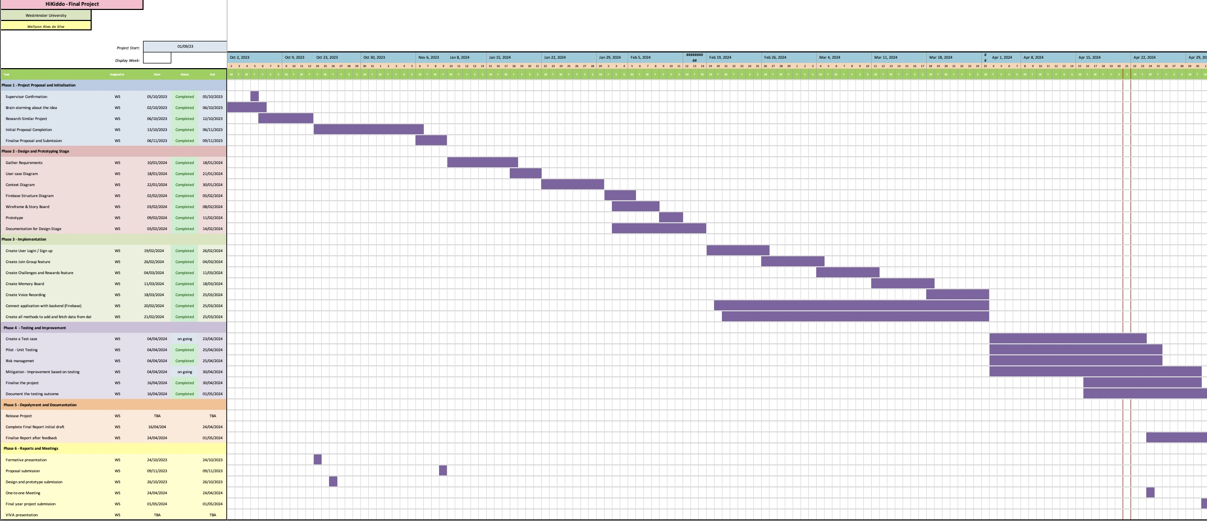

Additionally, tools like Trello and GitHub played vital roles in maintaining quality control. Trello was used to enhance task management through its user-friendly boards and lists. At the same time, GitHub was essential for managing source code and ensuring systematic tracking of all changes, facilitating smooth version control and integration.

# 5. Design

*Describe your final software structure using diagrams where necessary.*

*800 Words*

*Discuss in some detail (if relevant) issues relating to:*

* *User Interface*
* *Infrastructure*
* *Functionality*
* *Algorithm development*
* *Content creation*
* *Other*

*Discuss how these address the project requirements.*

*Use appropriate design methods for your project and extend your design to include implementation details that were not included in your Project Specification Design and Prototype (PSPD) report. e.g. make use of UML such as class diagrams, sequence/activity/state diagrams for complex algorithms and workflows, use UI design methodology and heuristics for predominately UX based projects. If you intend to develop an app/software/dashboard, you may have to use/create ERD, flowcharting, storyboarding, prototyping. It is up to you to use the appropriate design that best describes your implementation*.

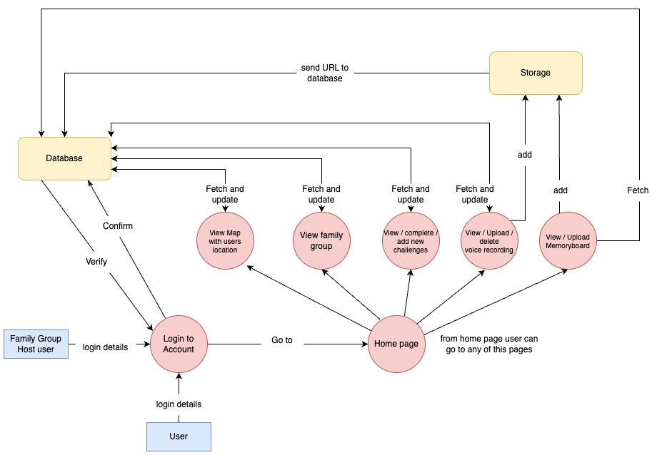

The diagram above presents an overview of data interactions within the “Hikkido “application, highlighting the roles of two user types: the standard User and the Family Group Host user.

Both types of users must go through an authentication process facilitated by the Firebase, which verifies and confirms login credentials. Once users are logged in successfully, they gain access to the Home page, from which they can access all the app features.

The diagram shows how data flows between the user actions and the database, supporting the app’s functionalities. For example, users can view and interact with a map displaying the current locations of family members, manage/view family group information, participate in challenges, and use a voice recording feature for sharing stories or messages. Additionally, there is a Memory board feature for uploading and viewing media tied to family memories.

This diagram effectively shows the dynamic interaction between the user's actions and the backend response, ensuring the app functions smoothly and efficiently.

User Interface

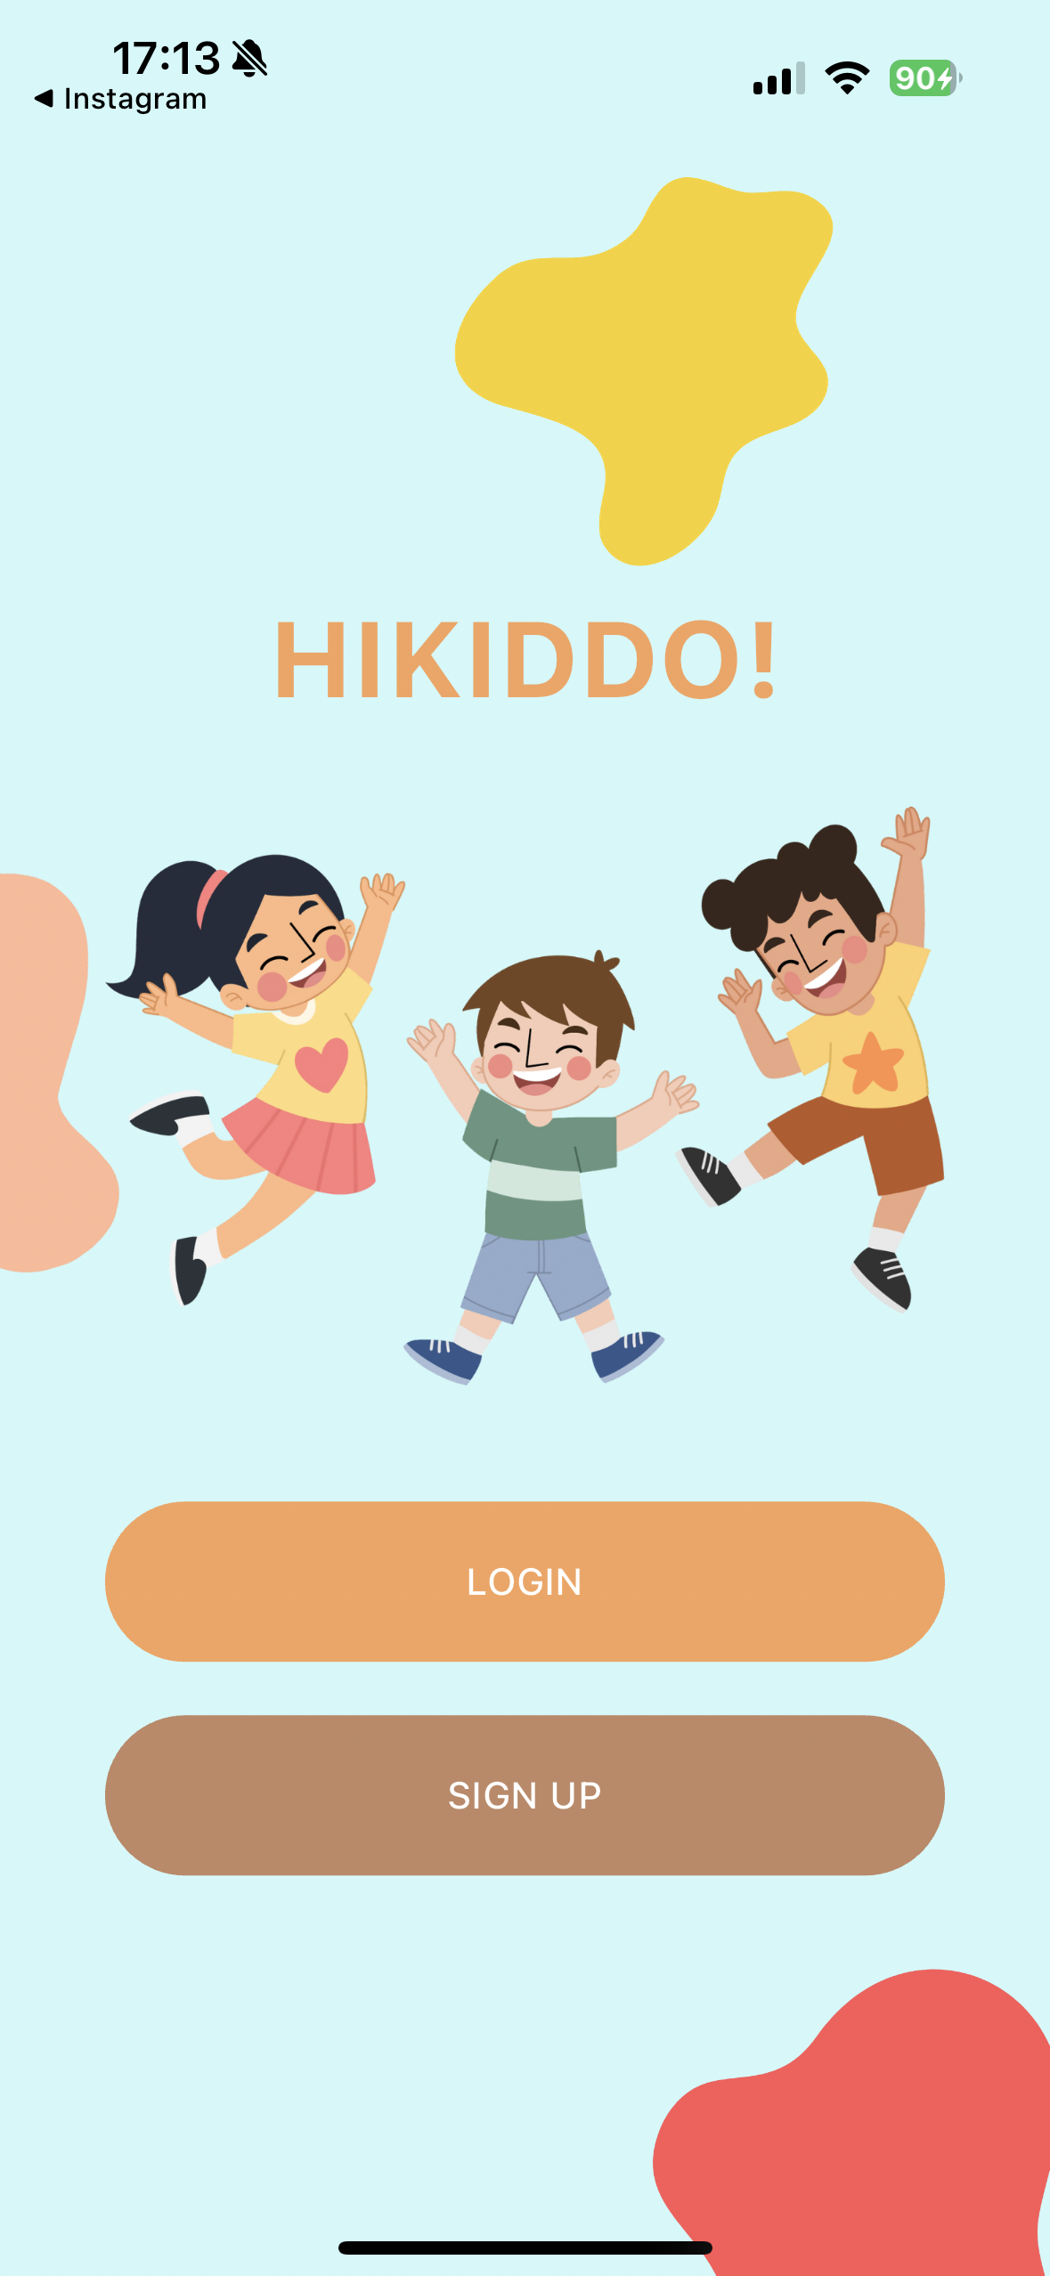 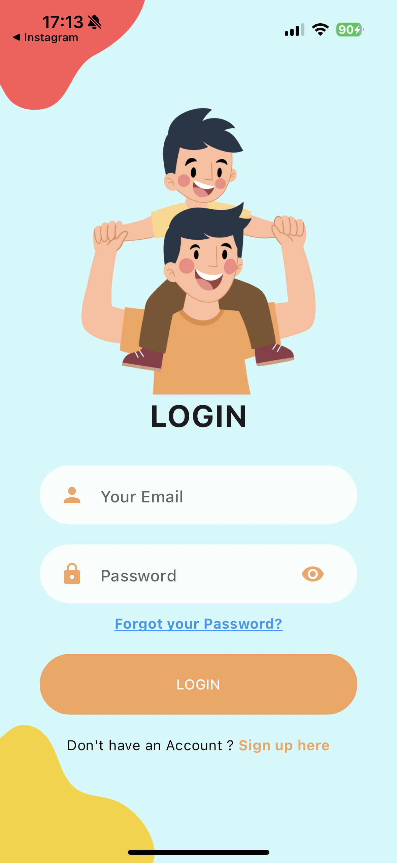 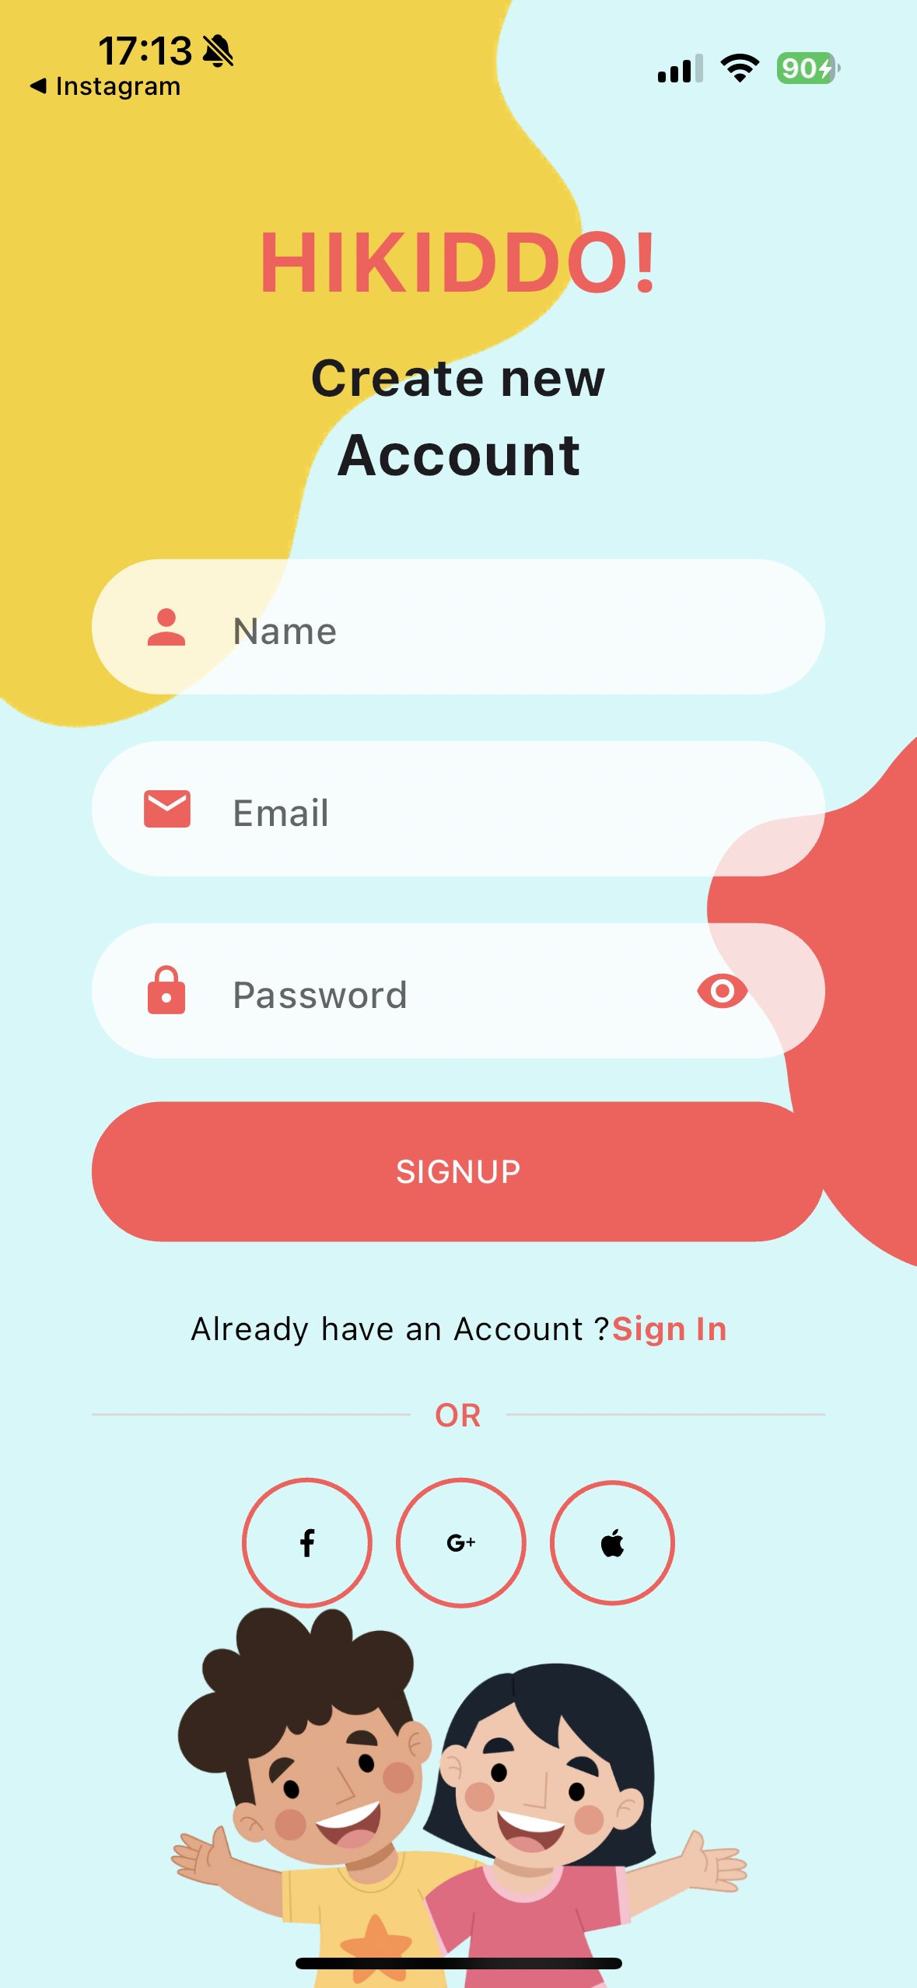

This is the starting page of the application, where the initial screen presents two choices: to log in or to sign up. Selecting either option will direct the user to the corresponding page for authentication or registration.

If users already have an account, they can log in and go to the application's home page.  
To create an account, the user must enter their name, a valid email address, and a password. The password should be at least 6 characters long, including at least one uppercase letter and one number, to ensure security. Currently, the signup options available on this page, such as Facebook, Google and Apple, are not functioning, but enhancing these features is part of my plan.

 

To complete the registration process, the user will be prompted to check their email for a confirmation message. They need to click on the link in the email to verify their email address. Once verified, the system will move forward to the page where they can join a family group.

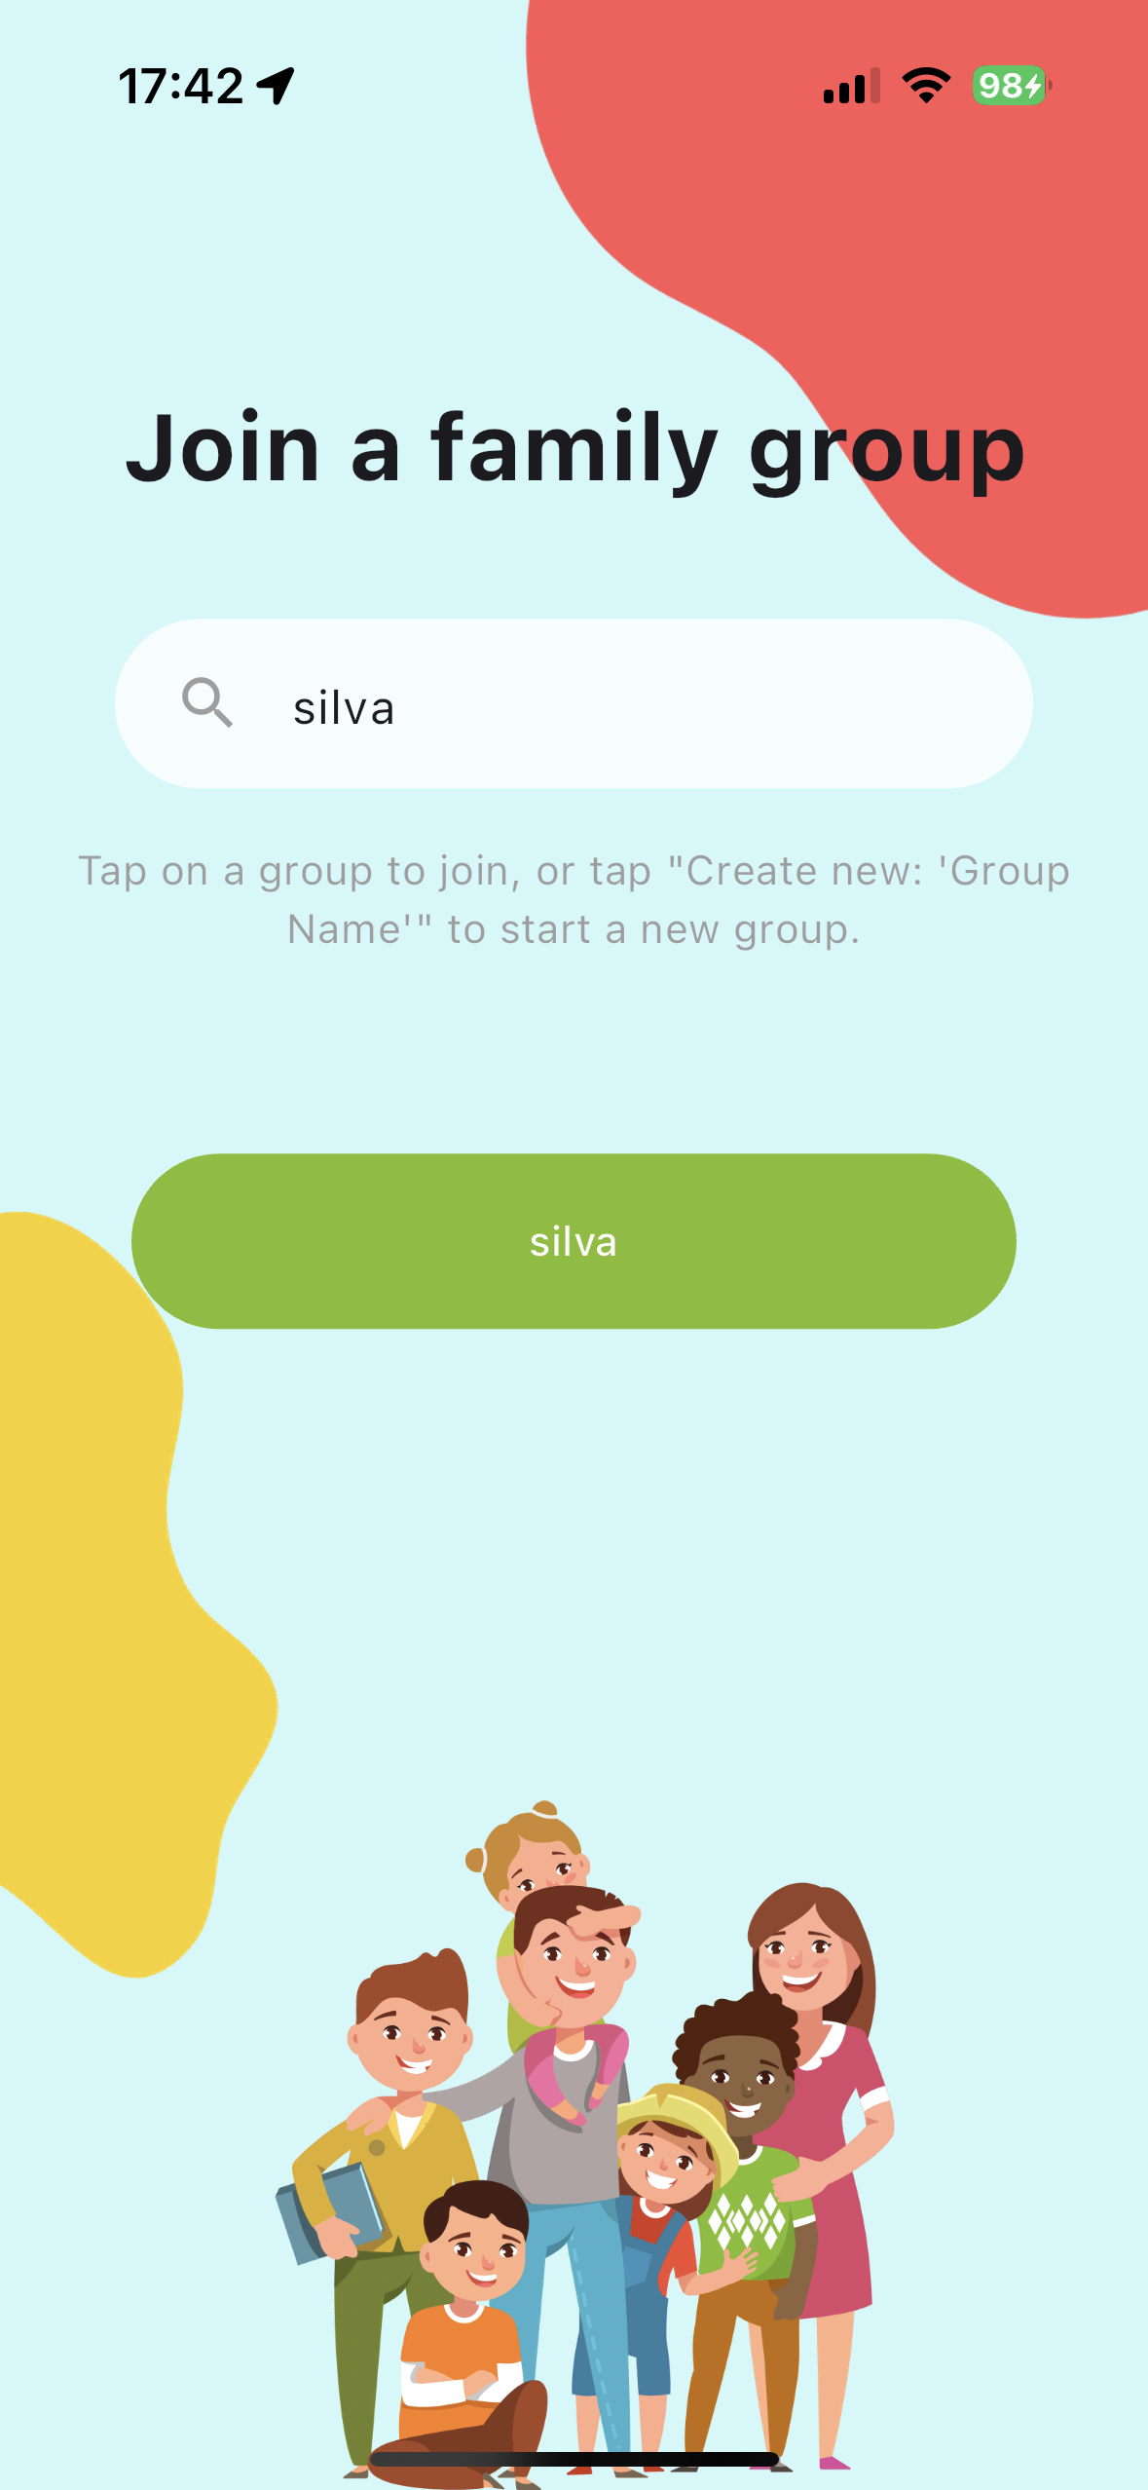 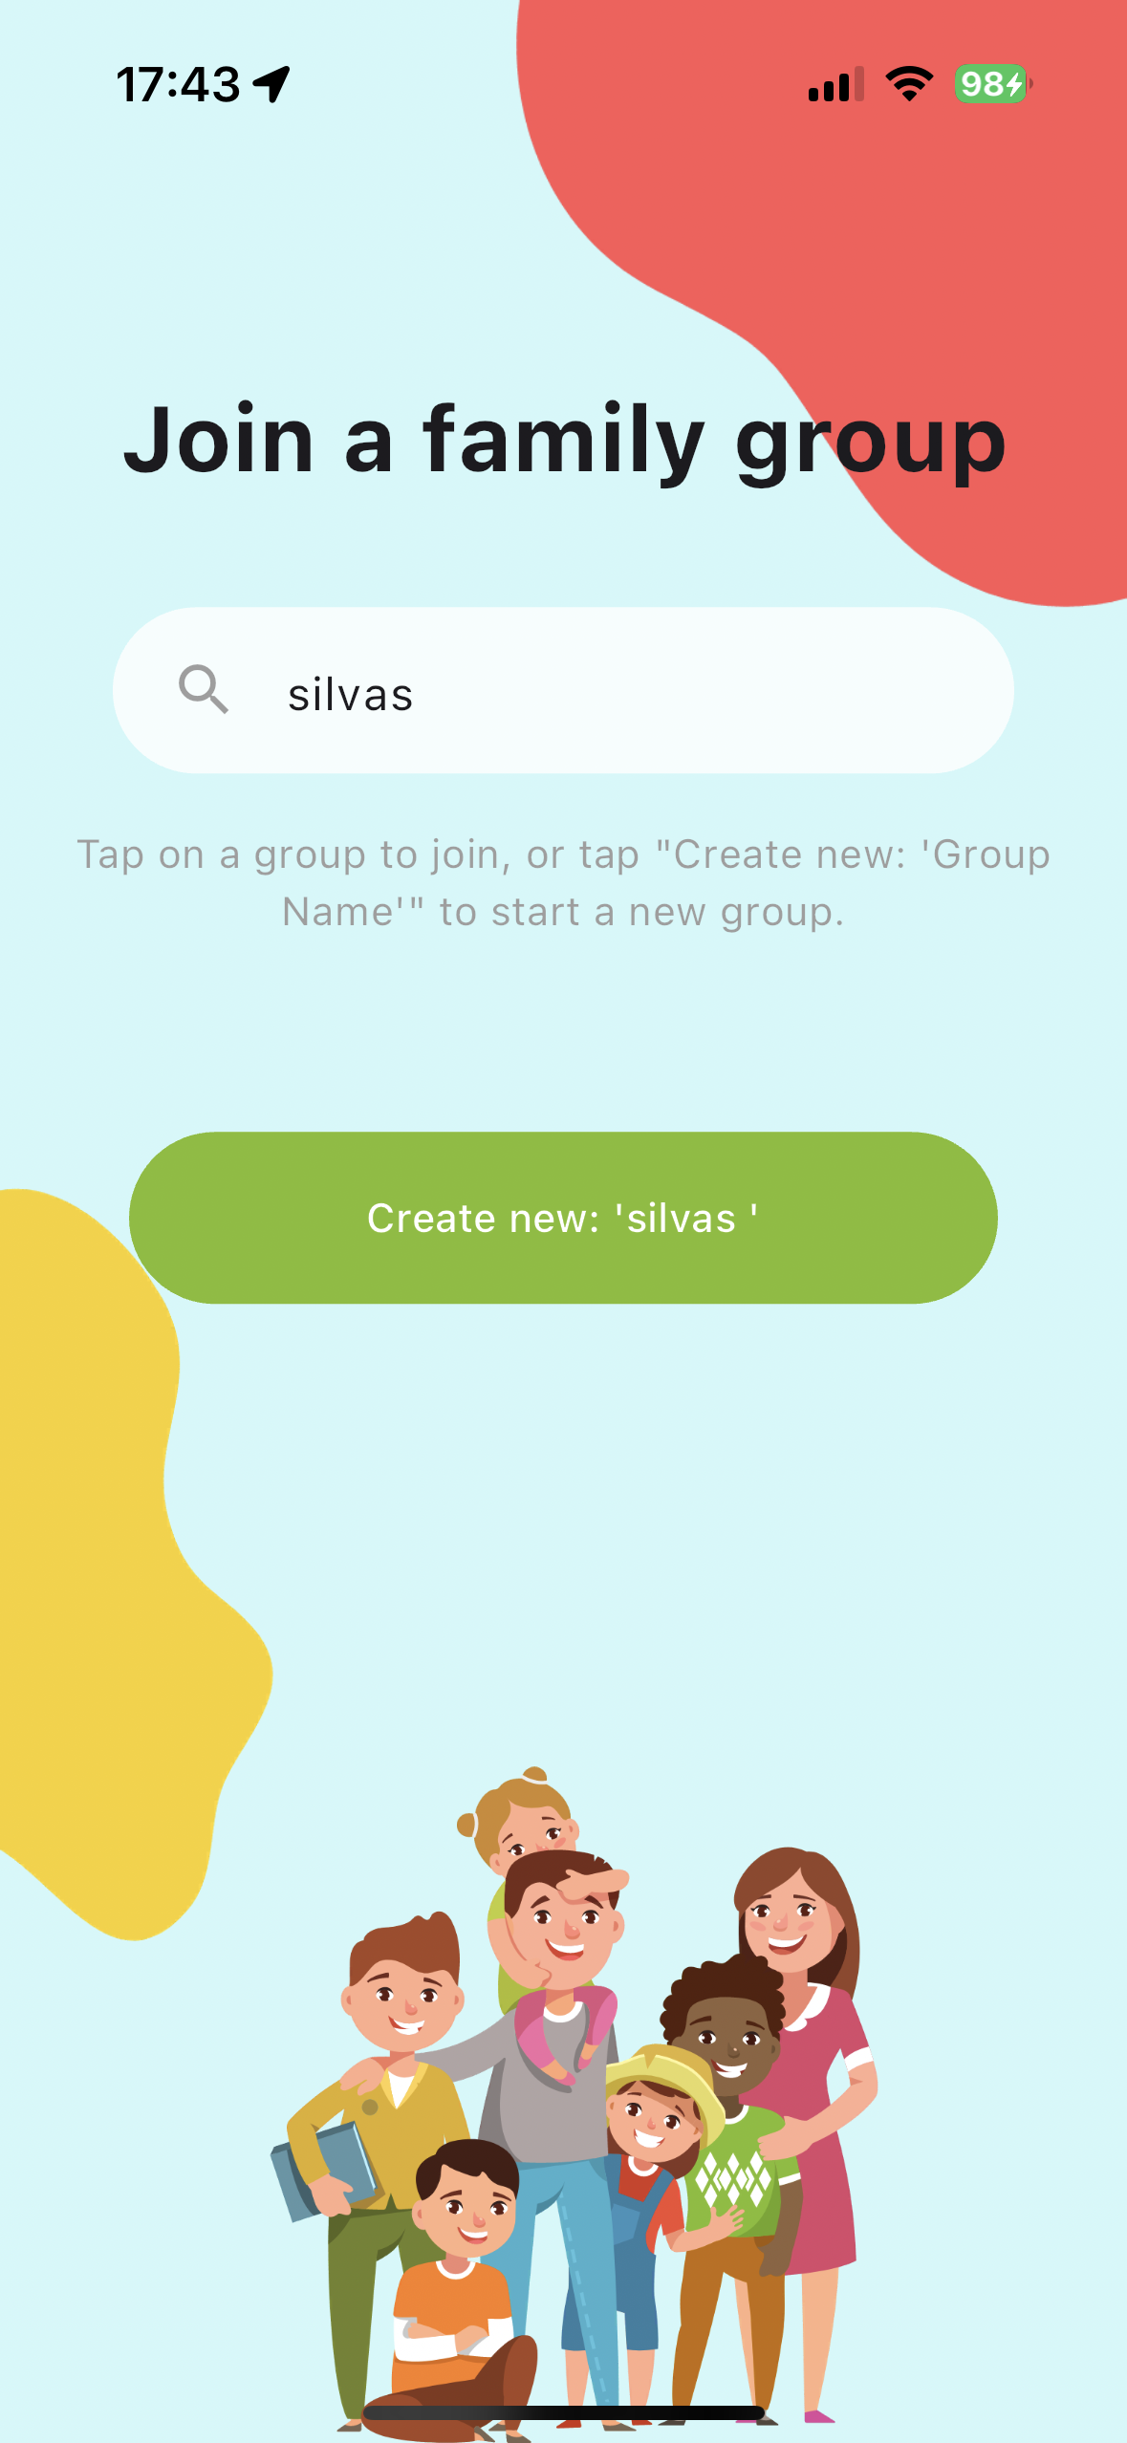 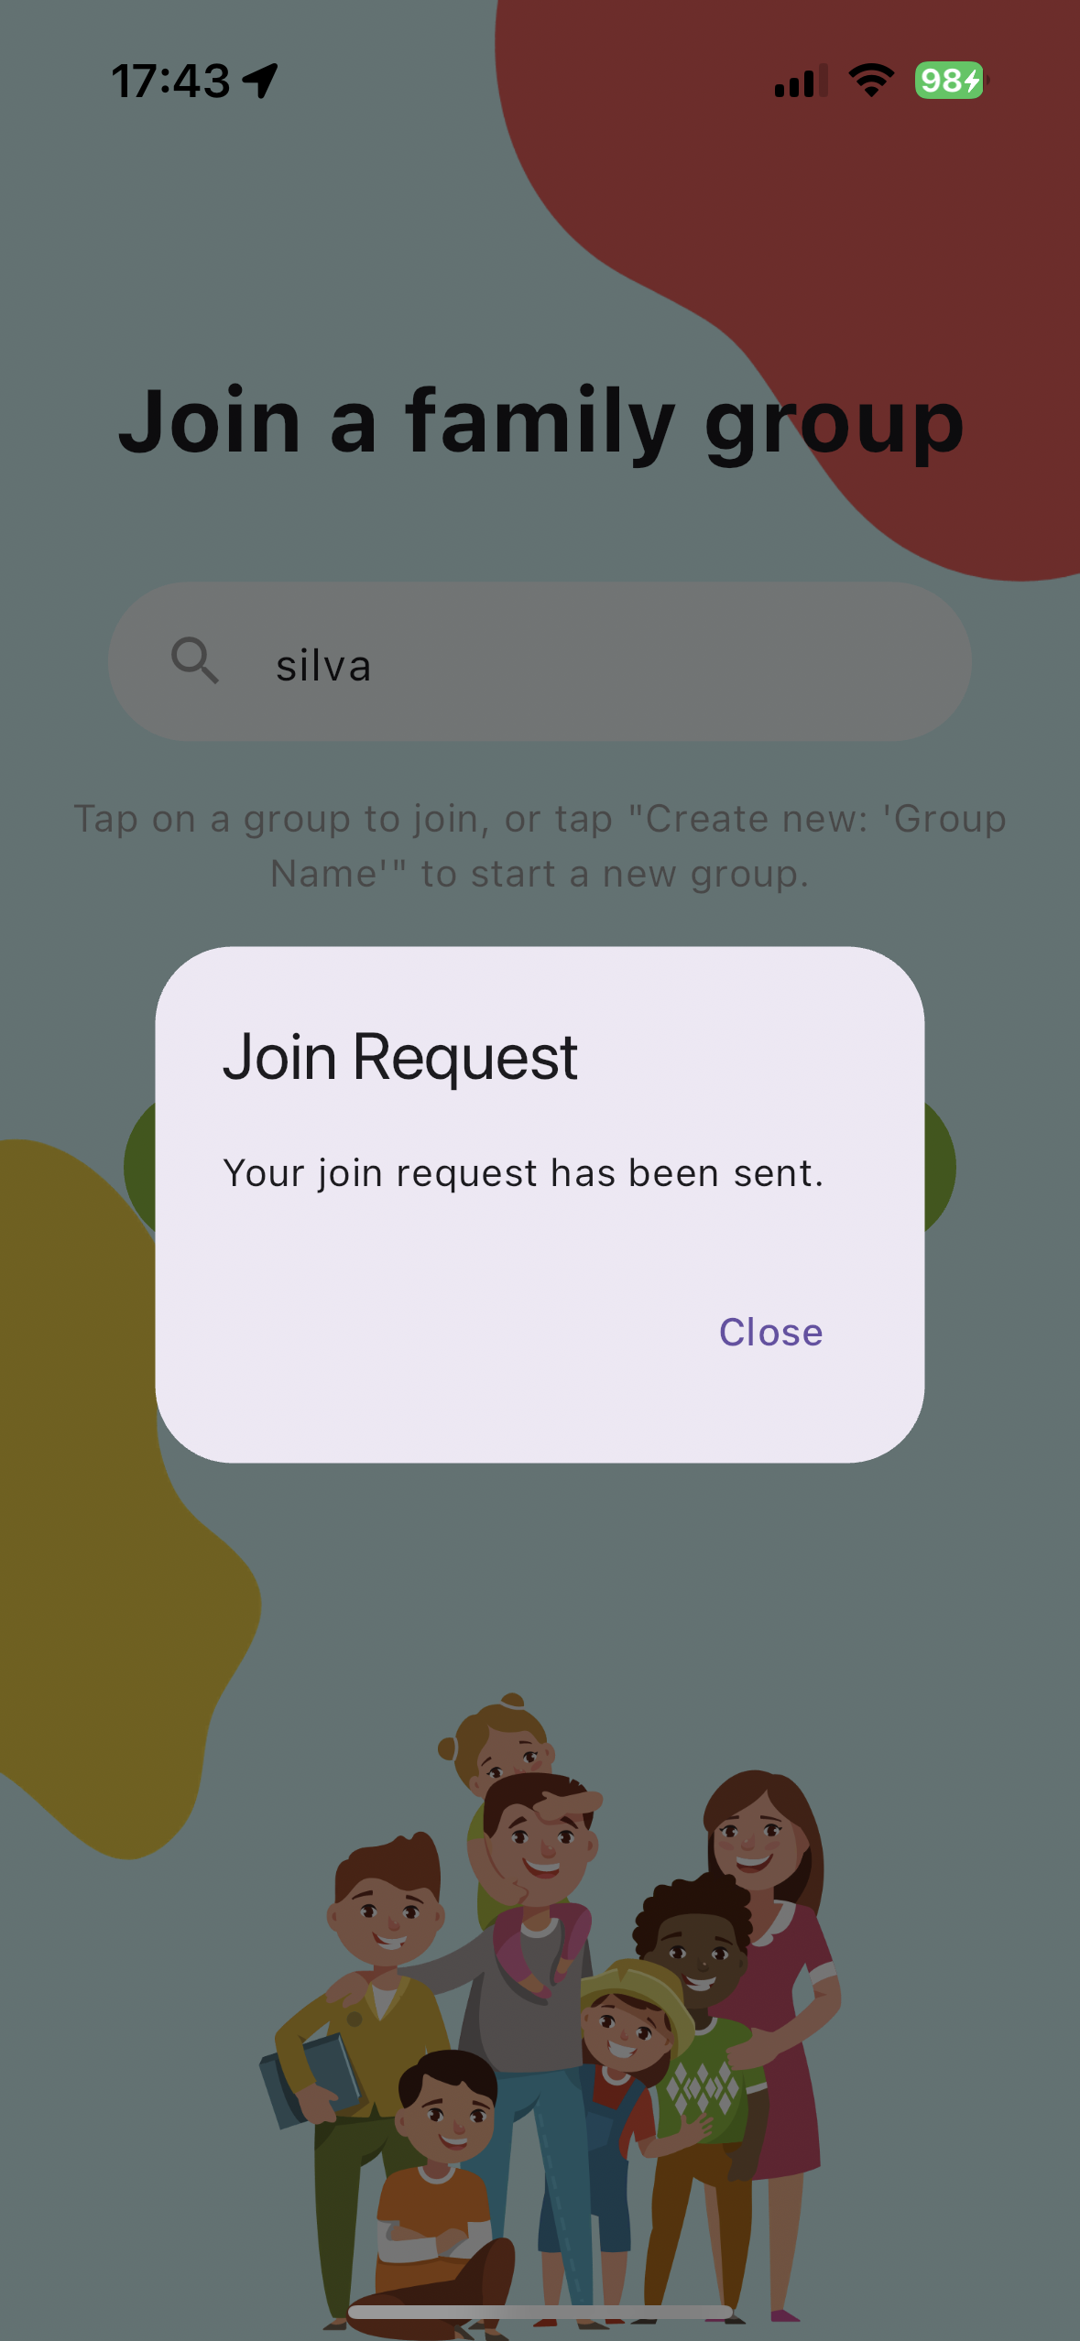

On the "Join Family Group" page, users can choose to either search for an existing family group or create a new one. If a search finds an existing group with the specified name, a green button showing the name of that group will be displayed. If no existing group matches the search, a green button will appear with the option to "Create new: ‘name of the group’".

If users decide to join an existing group, they will see a join request message and must wait for approval to gain full access to the app's features. However, if they choose to create a new group, they will automatically become the host of that group and can start using the app immediately.

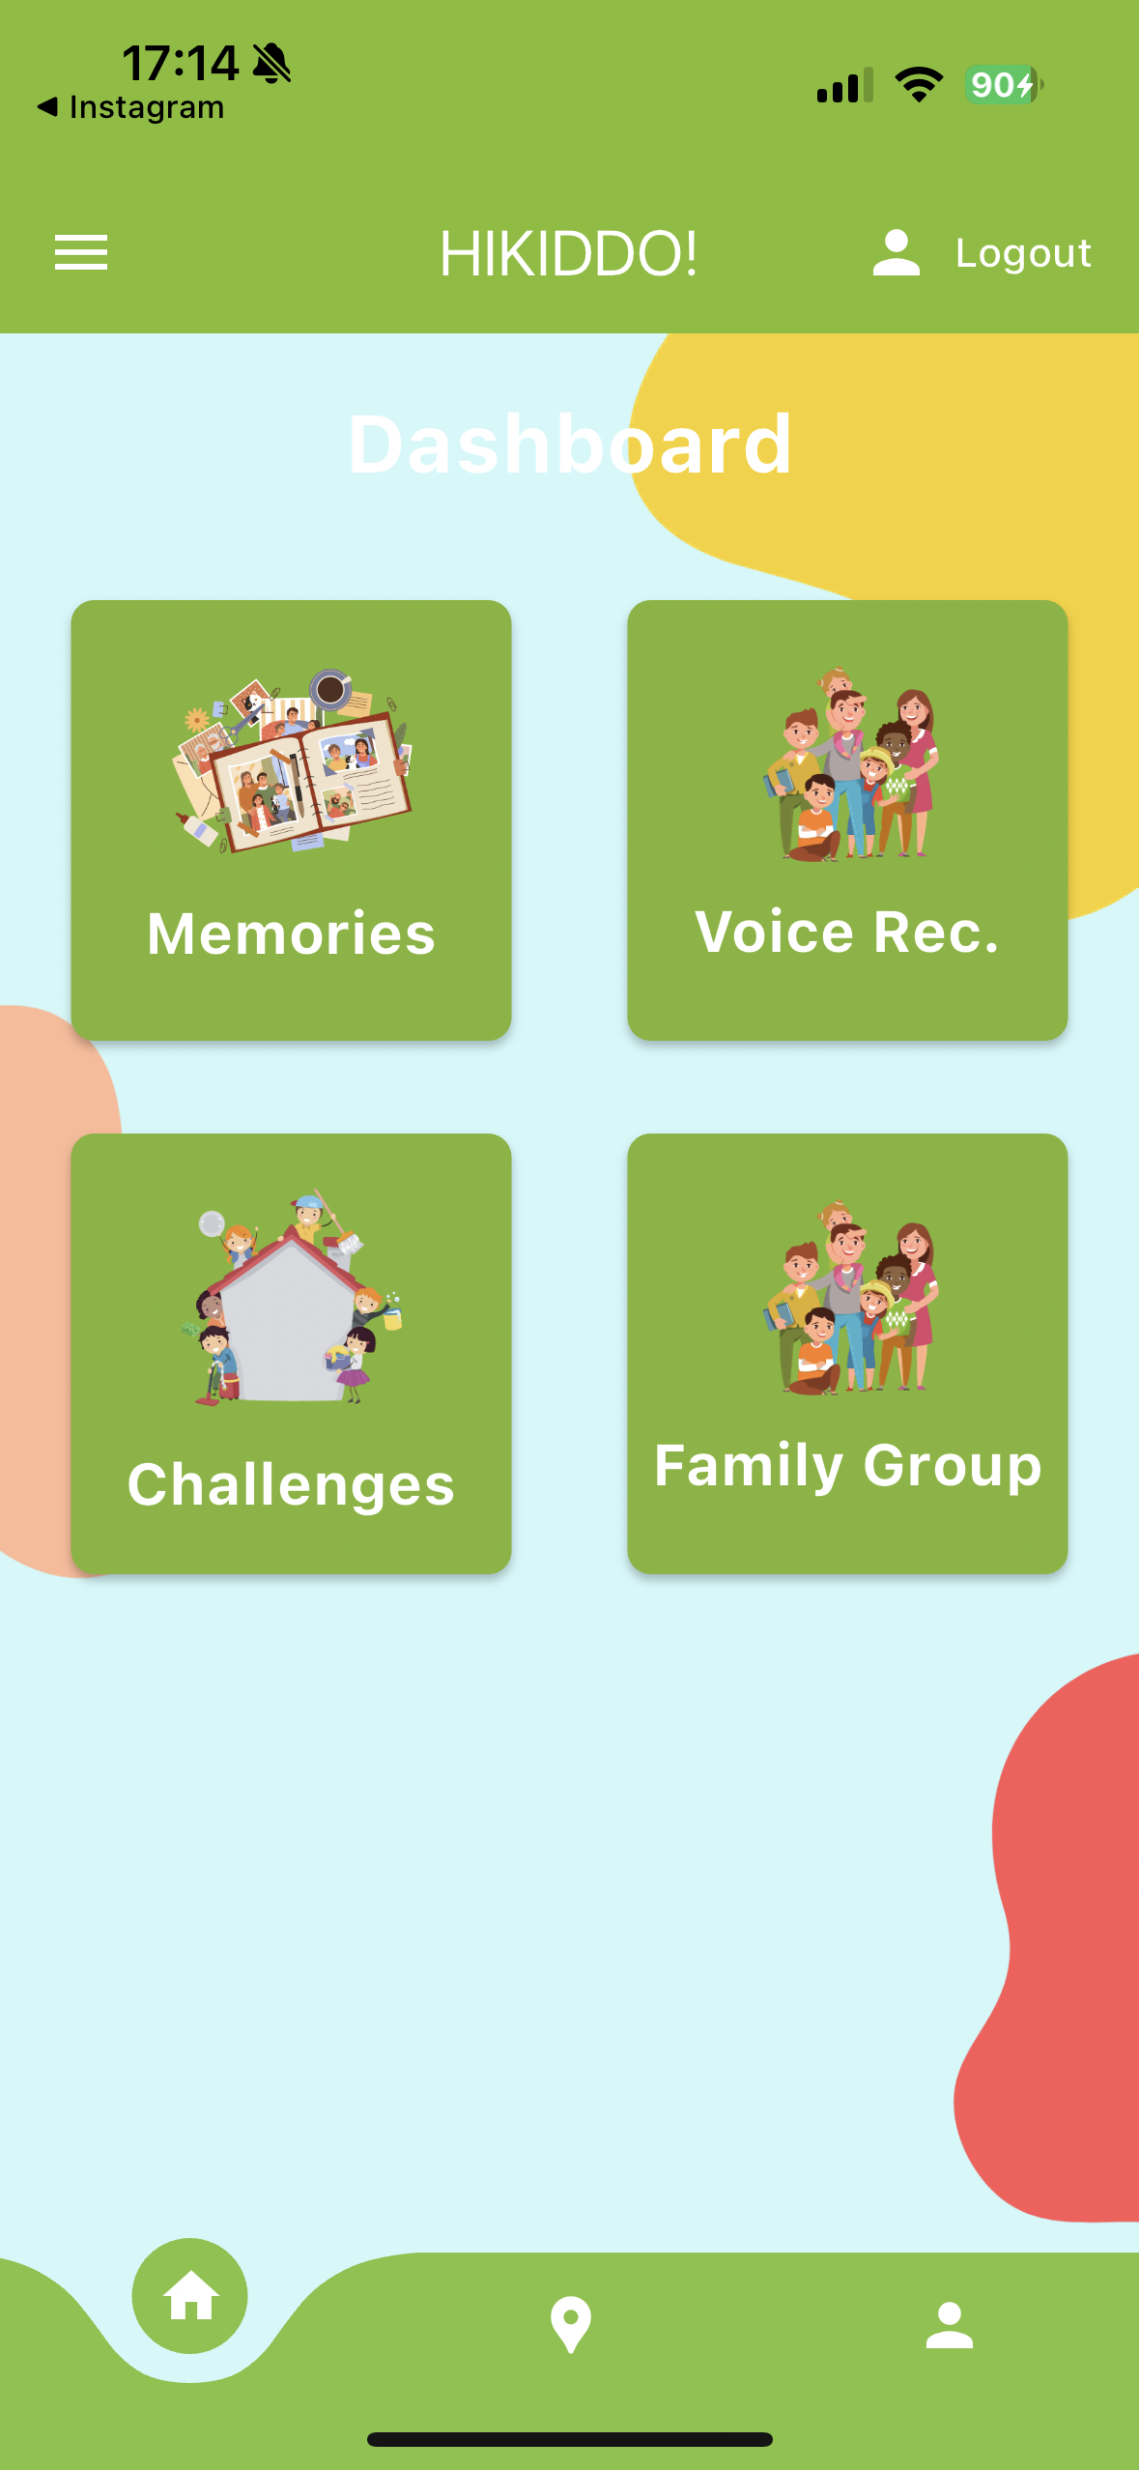

The home page is structured for straightforward navigation. It includes a bottom navigation bar that allows quick access to the home, map, and profile pages. In the central part of the page, four buttons are displayed: 'Memories' directs to the memory board feature, 'Storyteller' is for voice recordings, 'Challenges' leads to current tasks, and 'Family Group' accesses group management options. At the top of the page, a top navigation bar features a logout button and a burger menu. Opening the burger menu reveals a sidebar that links to the 'About' and 'Contact' sections.

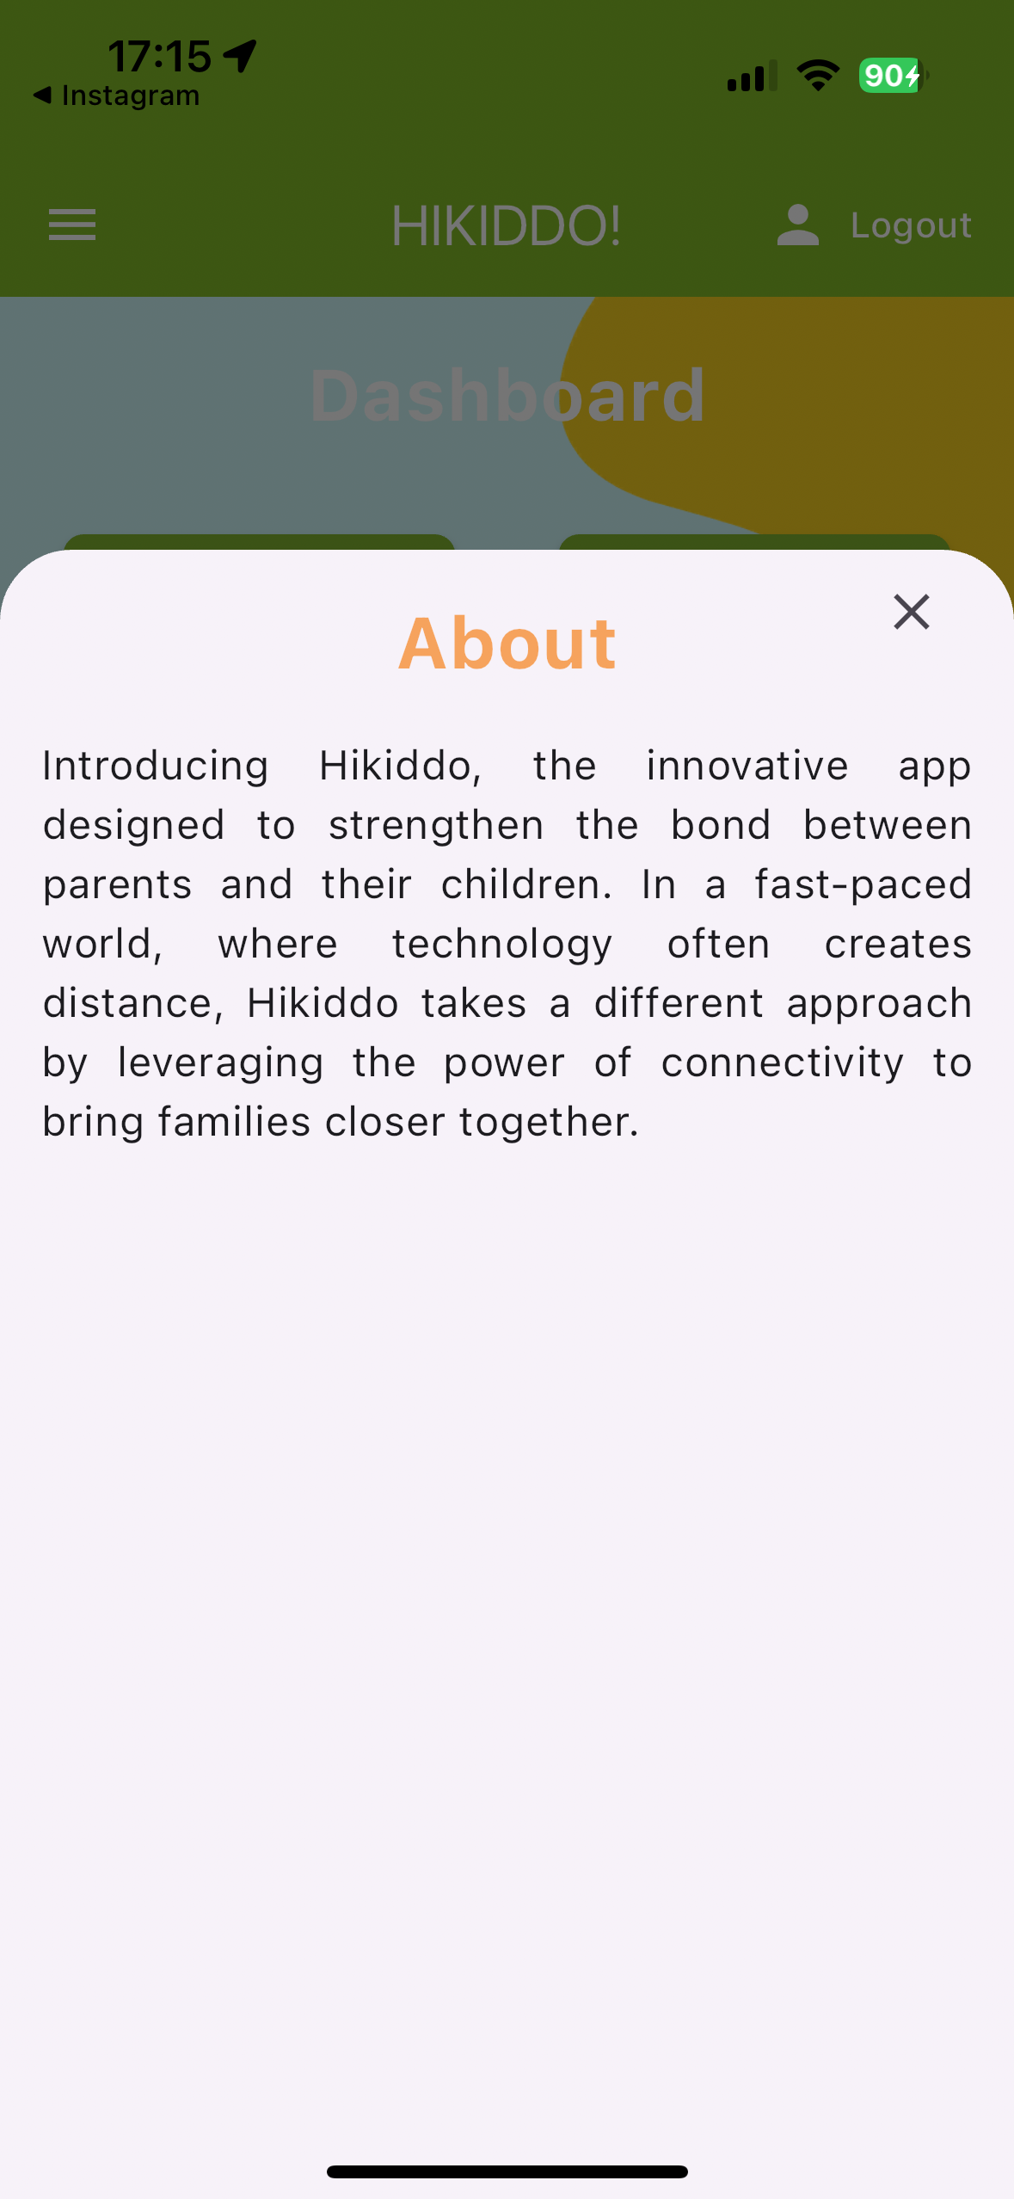 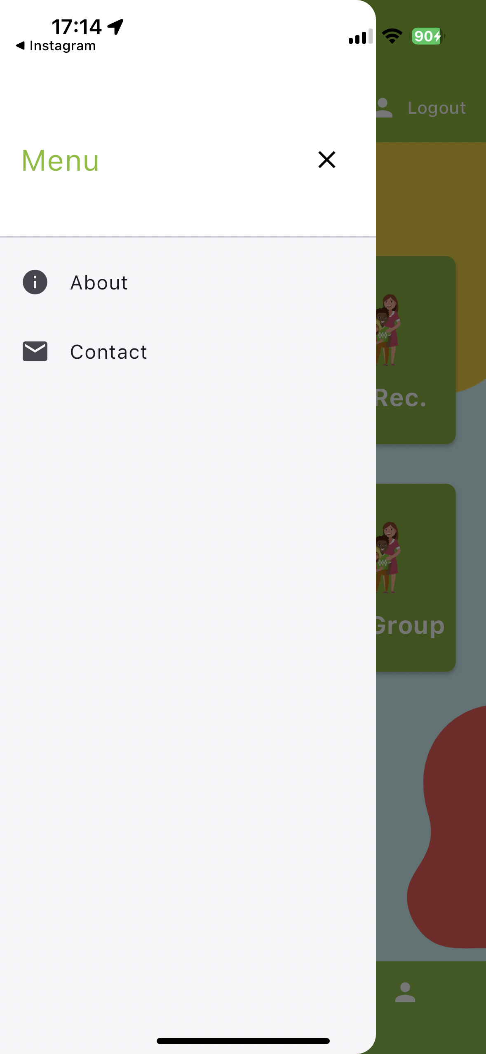 

Sidebar Menu: This menu appears when you click the "burger" icon at the top navigation bar. It includes links to the About and Contact Us pages. Clicking these options brings up a bottom sheet with the relevant information. For instance, on the Contact Us page, to reach out to the Hikiddo support team, just click on the email link. This will open your email application, allowing you to compose and send an email directly. Refer to the image above to see examples of how this setup looks.

The email address "support@hikiddo.com" is provided here as a hypothetical example for illustrative purposes only.

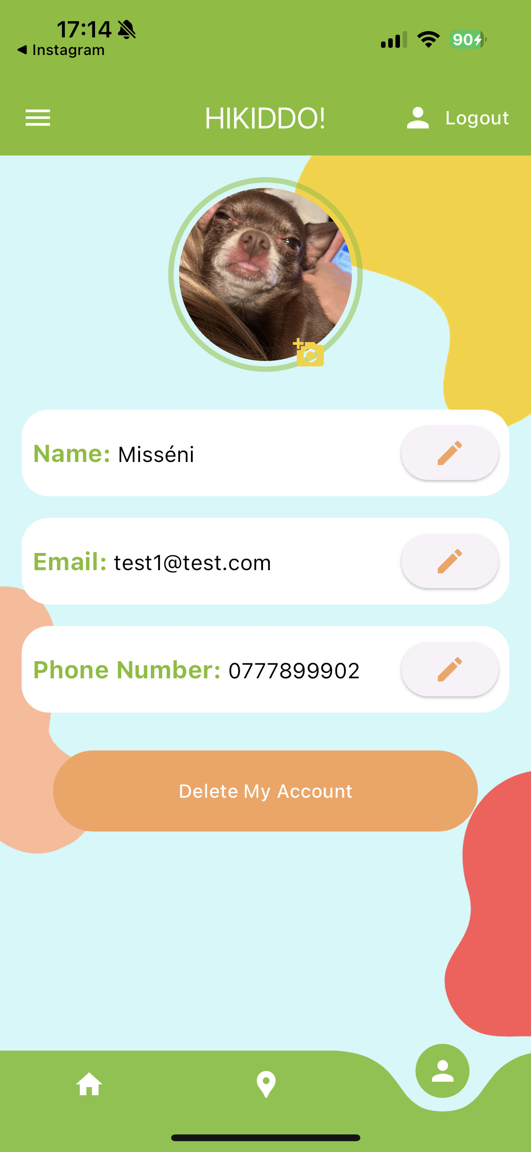 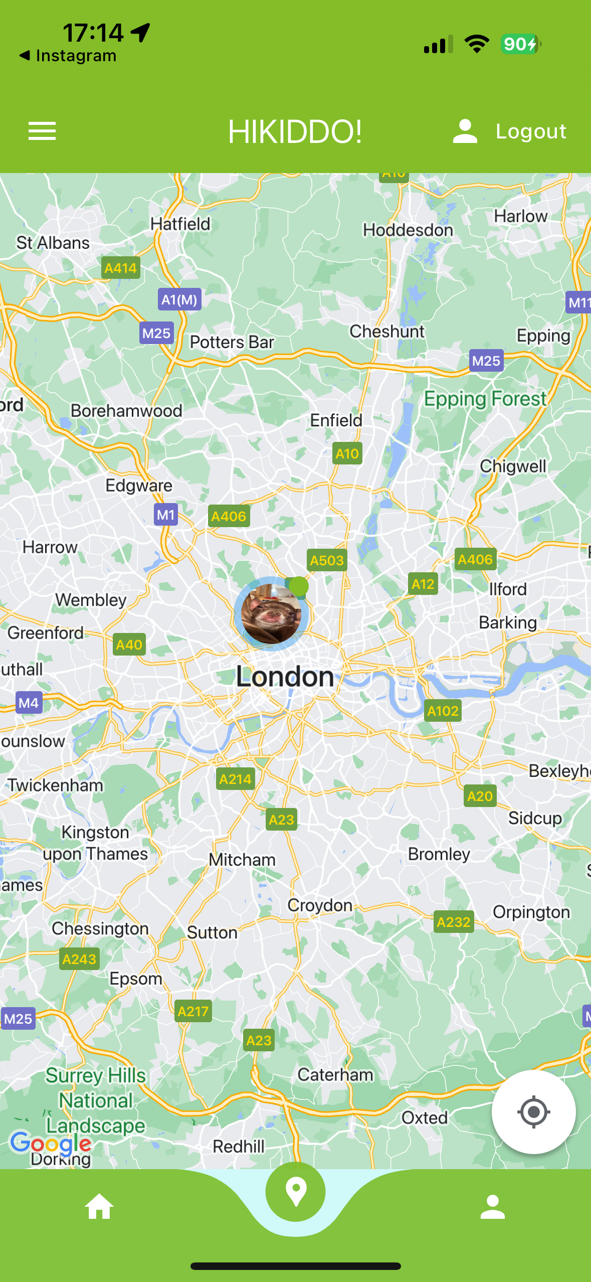

Profile Icon in the Bottom Navigation Bar: This section displays user information and the options to update their name, email, and phone number. Users can also upload a profile picture, which will appear as their avatar on the location pinned in the map view. Additionally, on this page, there is an option to delete their account.

Location Icon in the Bottom Navigation Bar: This section displays a Google Maps view, showing the current locations of all family members on the map. It's important to note that the zoom-in and zoom-out features might not work as smoothly in the mobile simulator as they work in the fully deployed mobile app version.

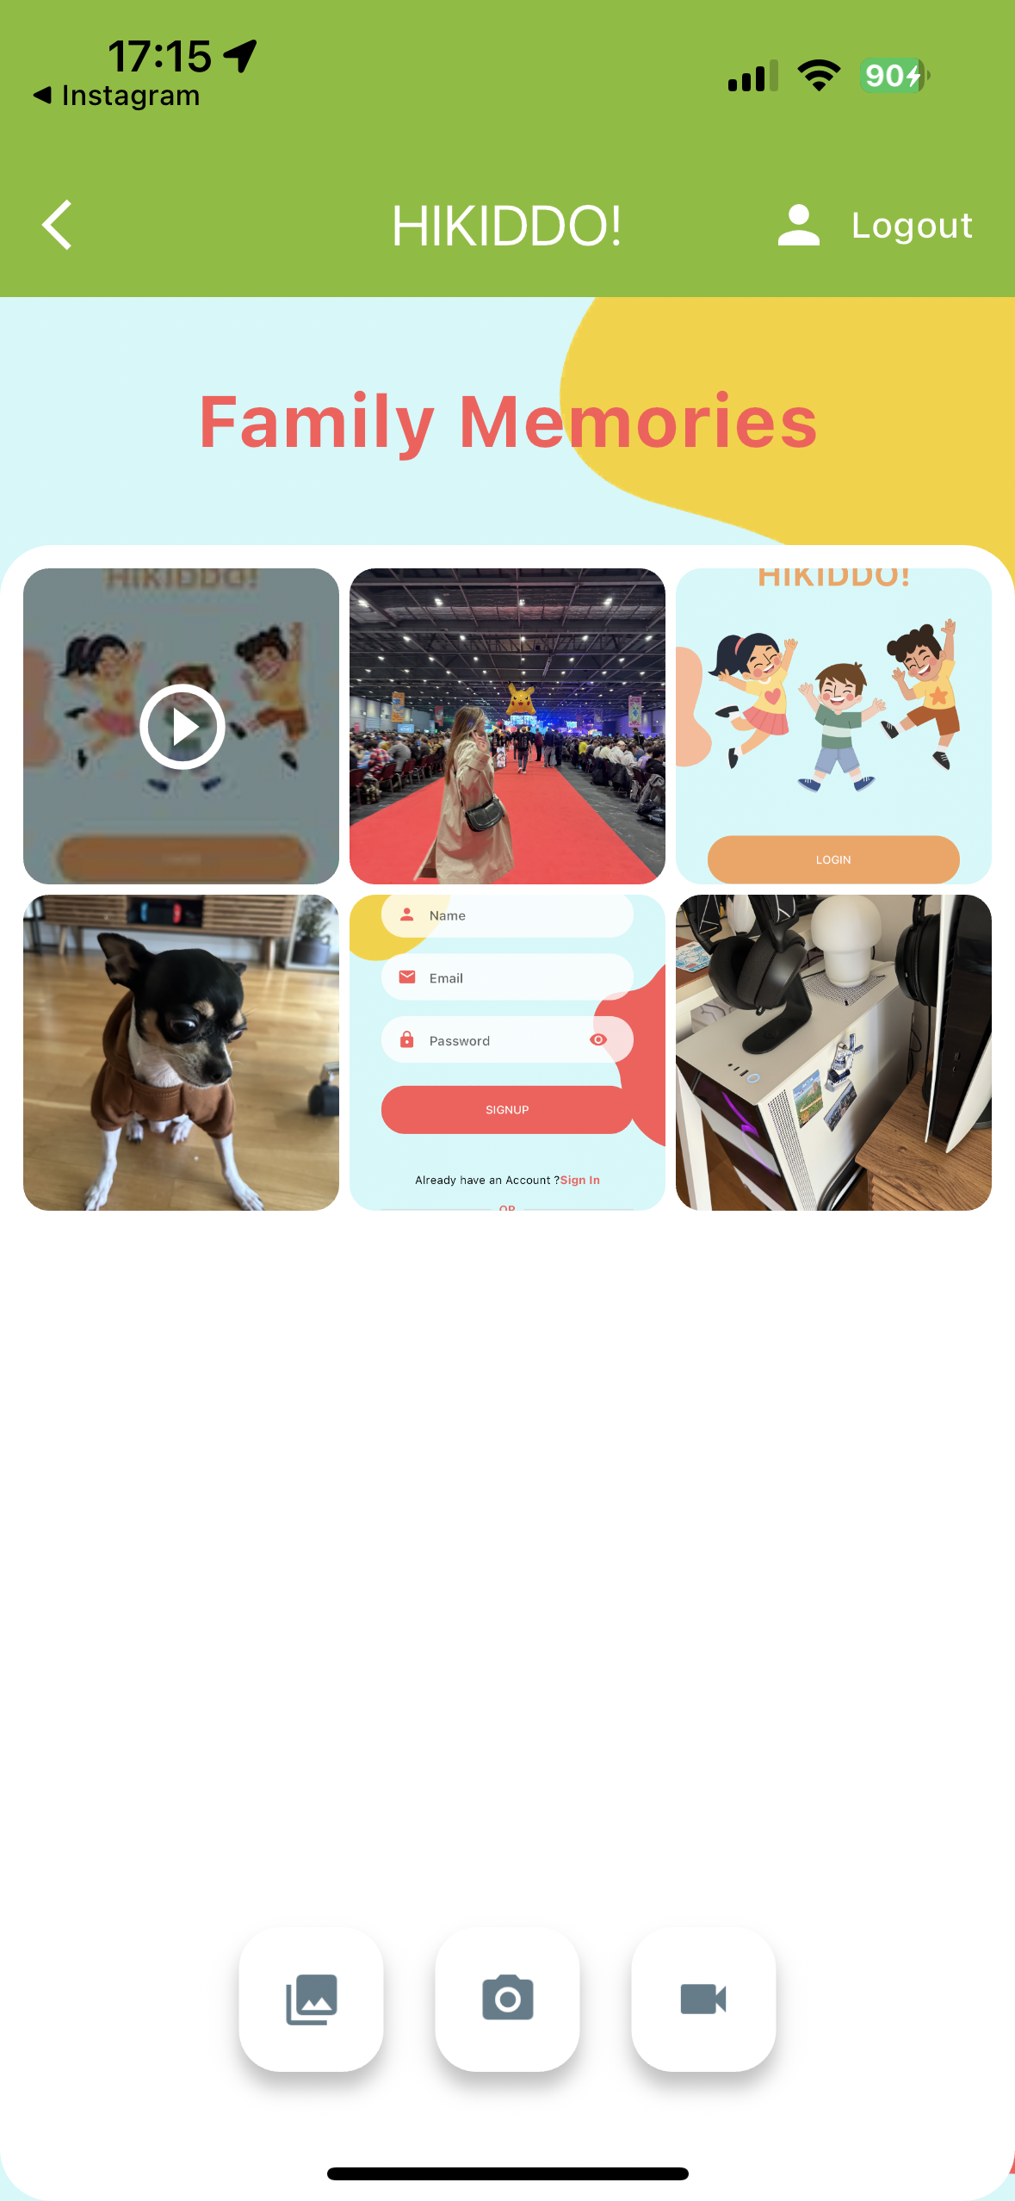 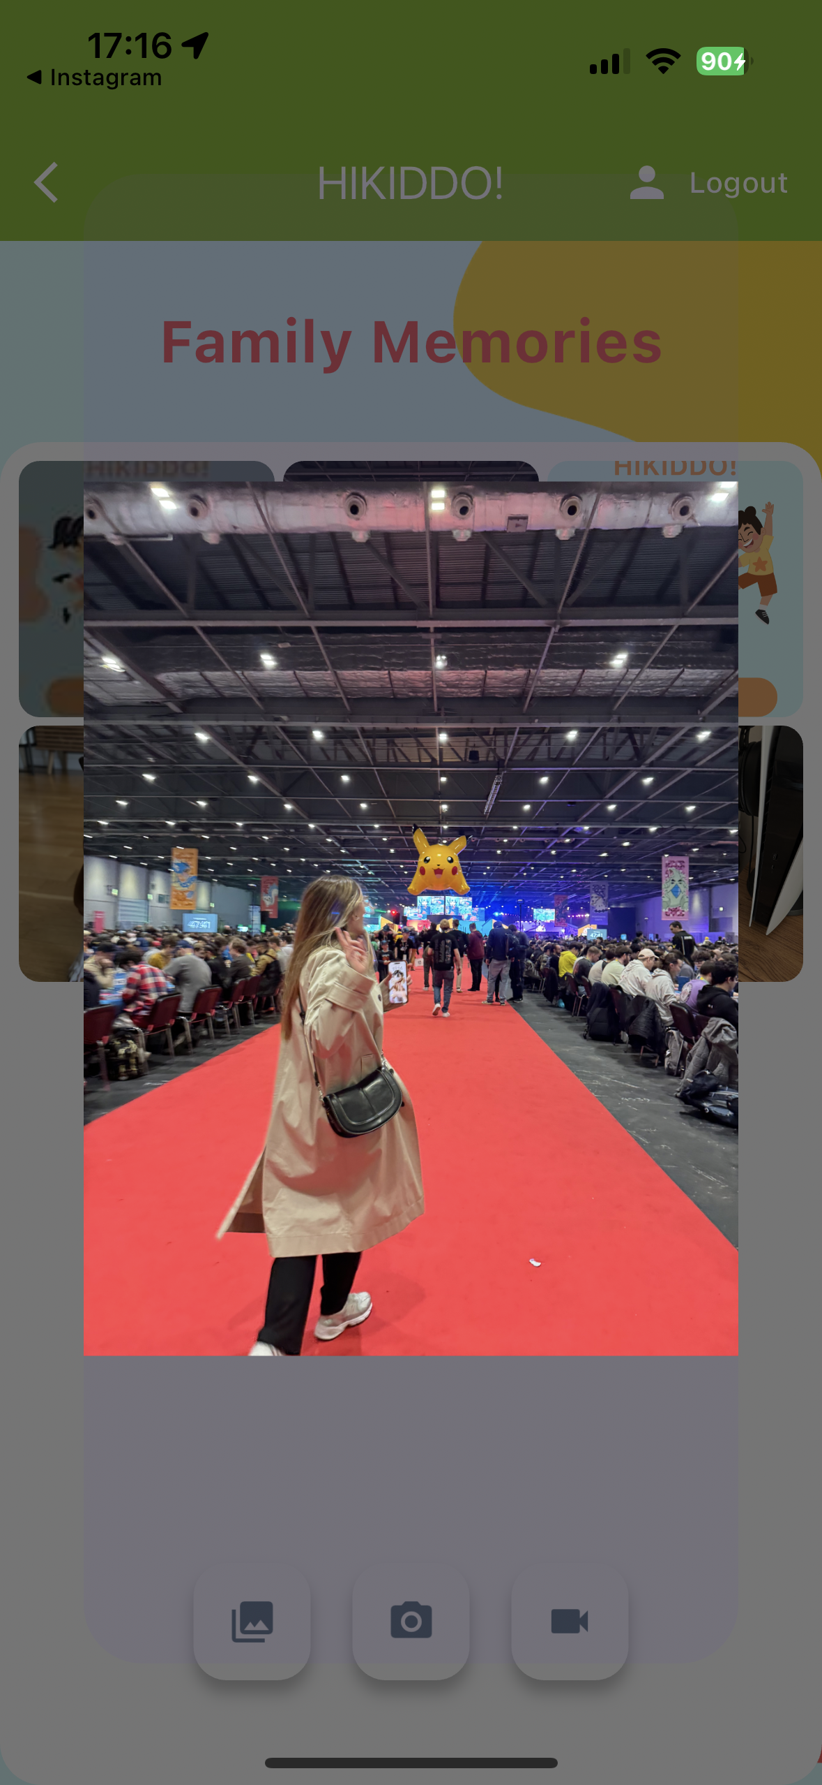

Memories: This feature offers a place for users to share and preserve family memories. They can upload videos or photos from their gallery or capture new moments using the camera icon for photos and the video icon for videos. To view a photo or video in more detail, click on and that media will be displayed on a large scale; clicking on a video will start the auto-play, with a replay button appearing after the video ends.

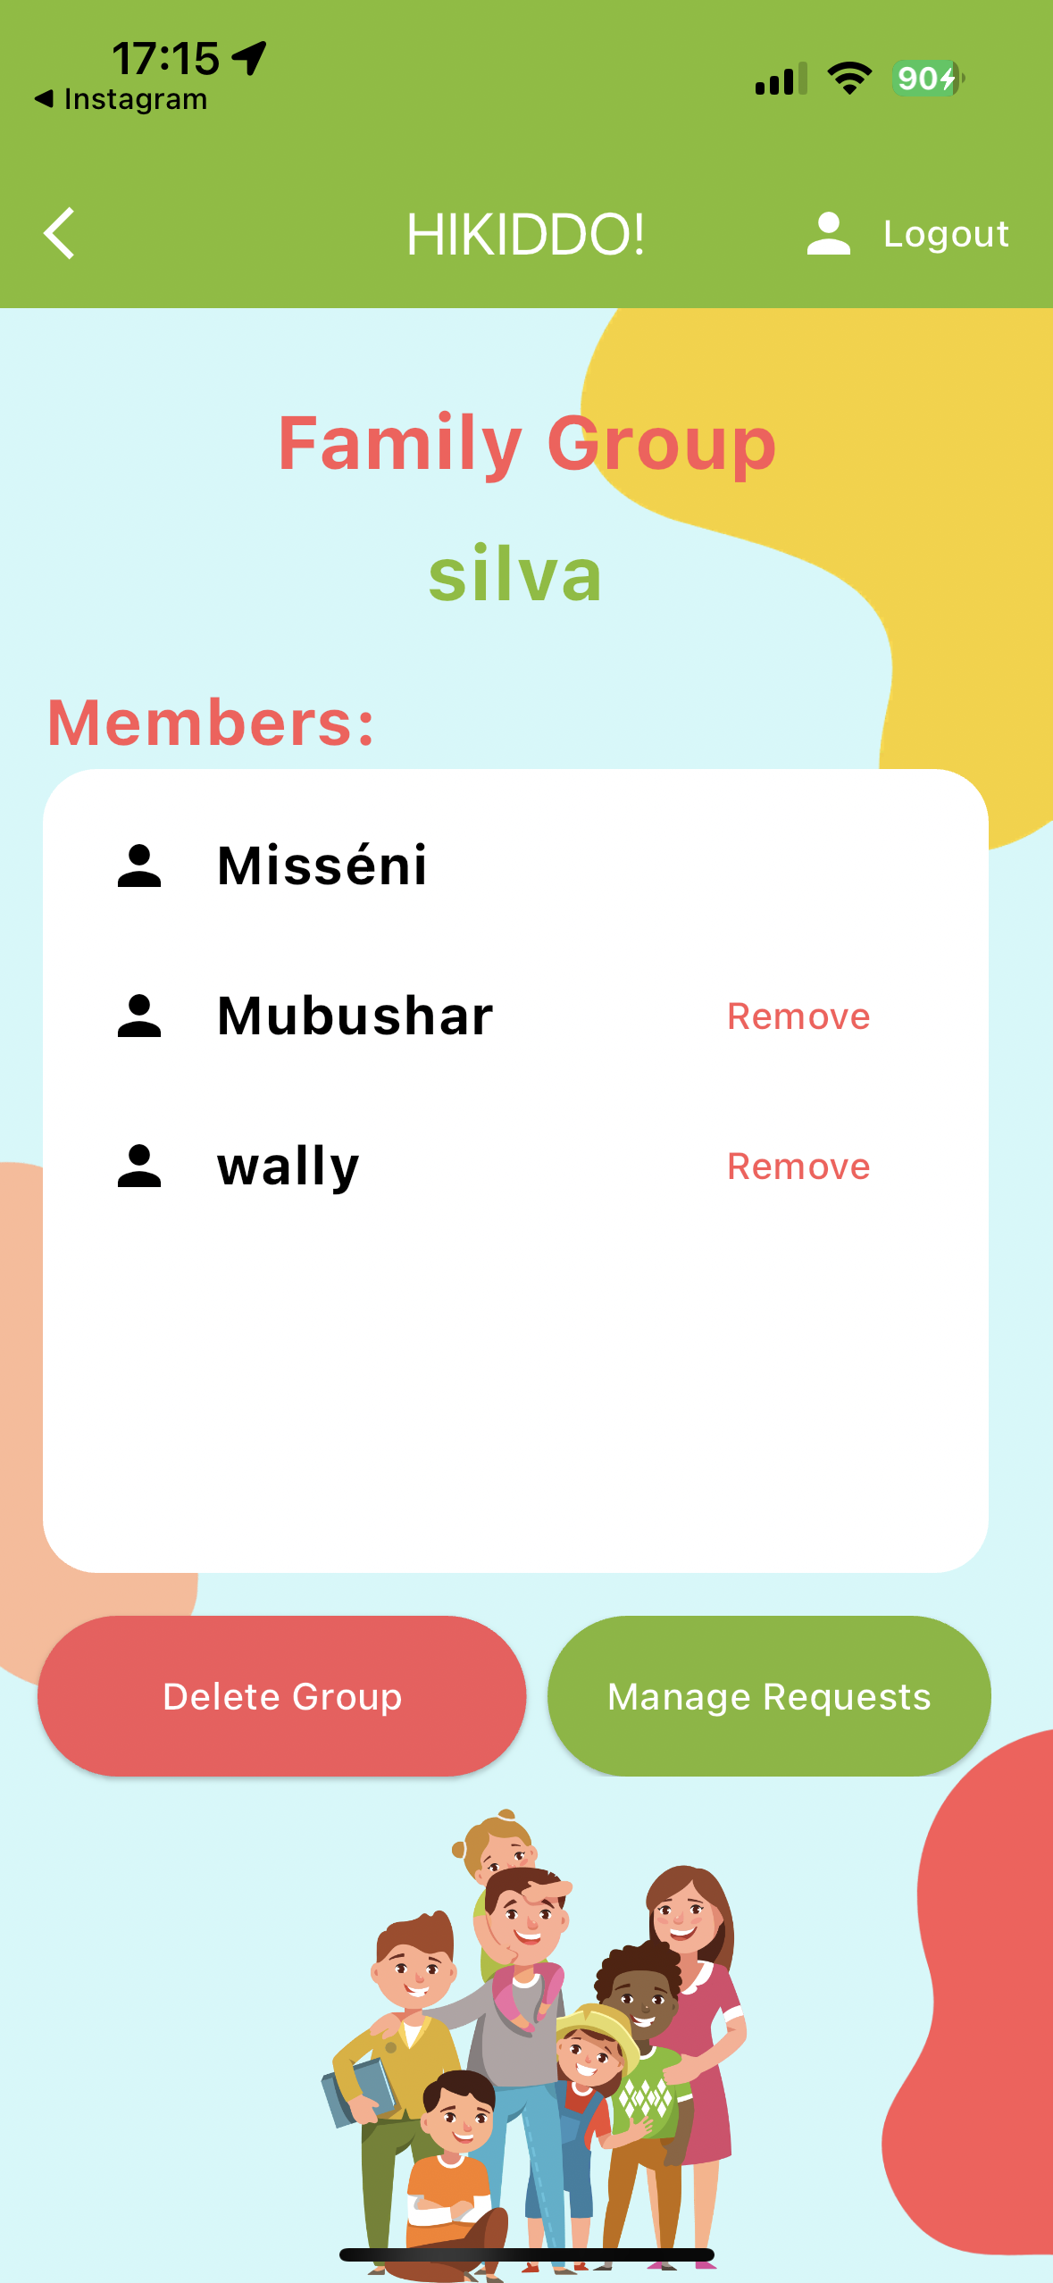

Family Group: In this section, users can view all the members of their family group and have the option to leave the group if they wish. When the host user accesses this page, they have additional privileges, including removing a family member from the group, accepting or declining new members, and deleting the entire group. If a user chooses to delete the group, all information related to this group will be removed from the database, although this action does not delete the user's account.

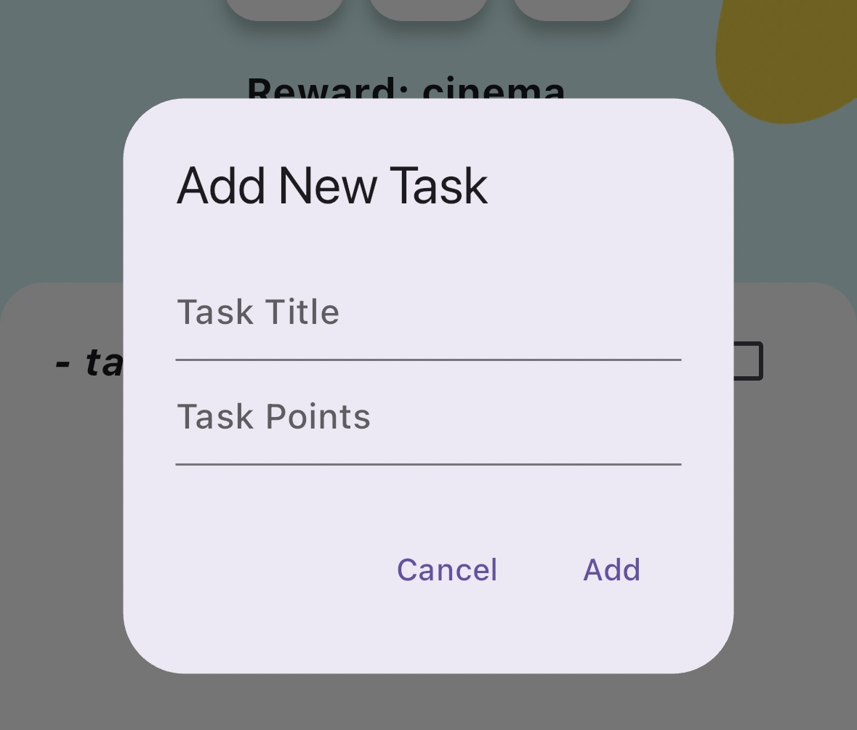

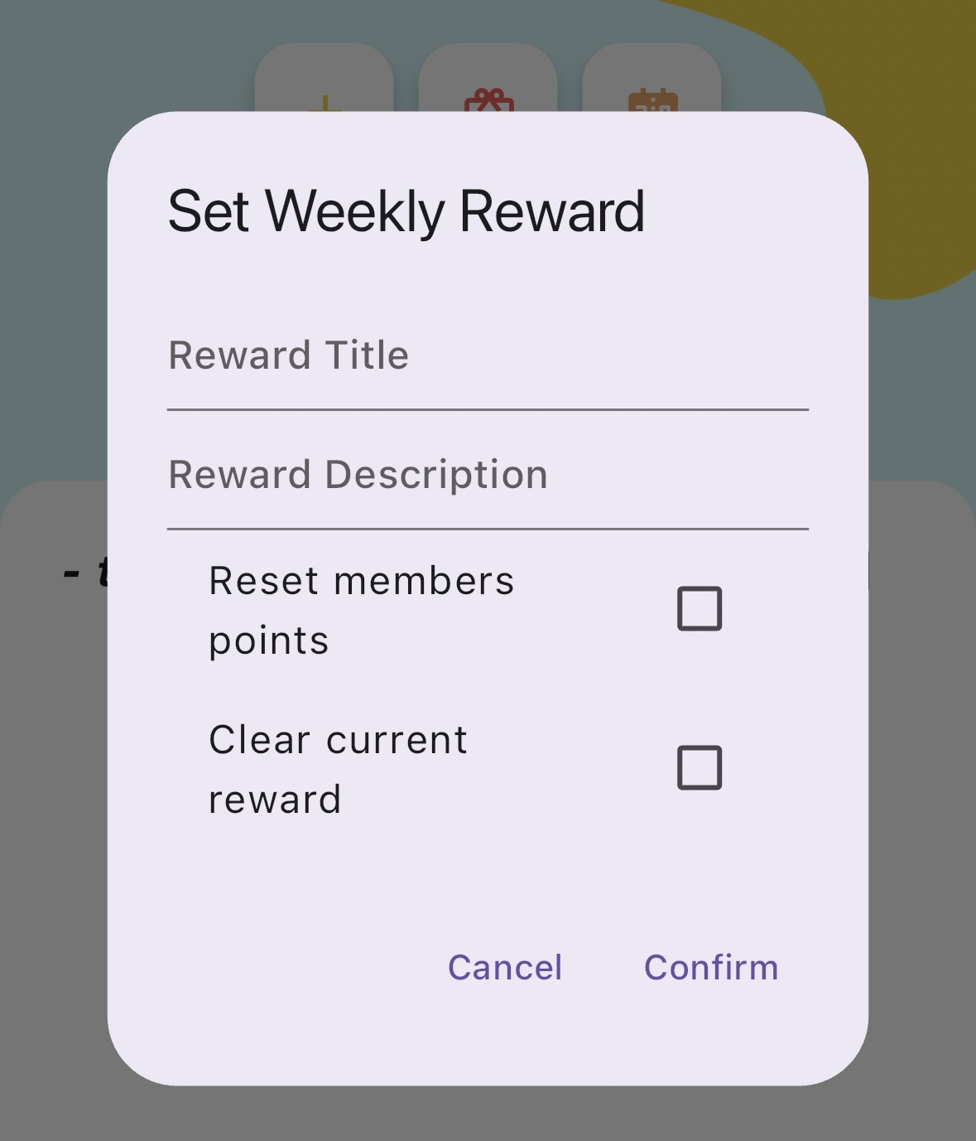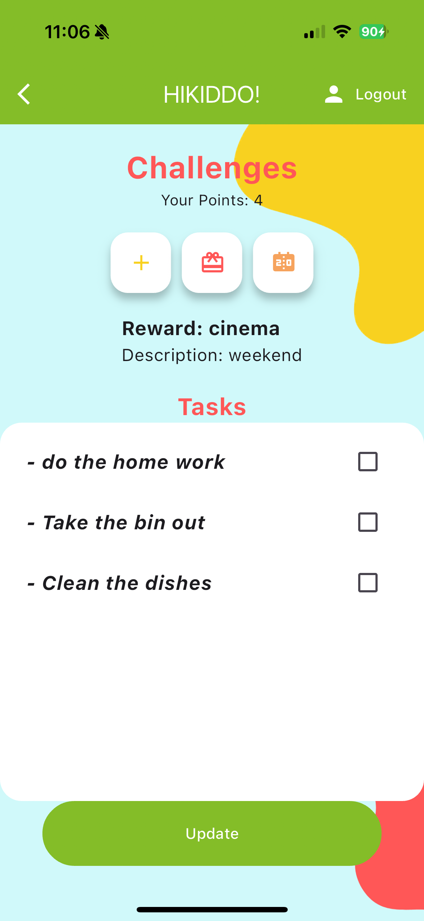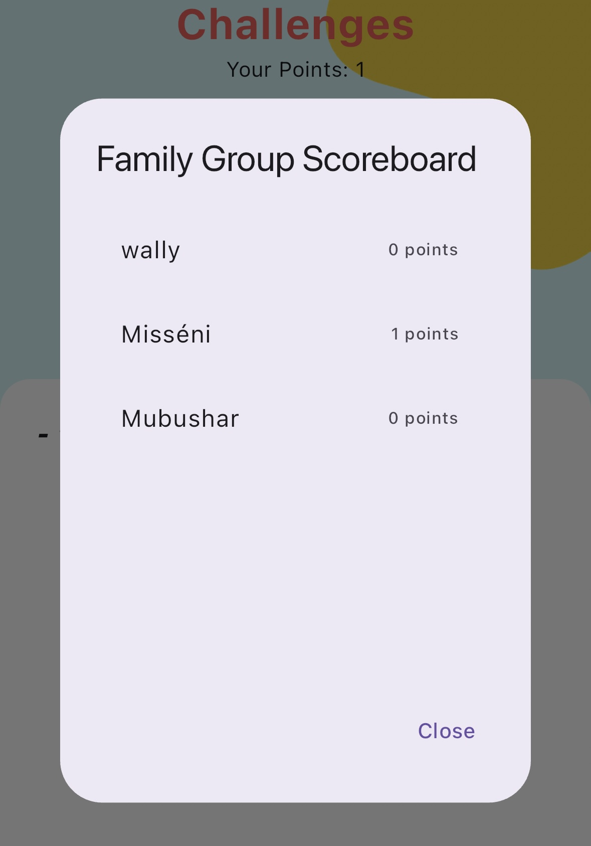

Challenges: This page allows users to complete tasks, earn points, and receive rewards set by their parents. Host users have additional privileges, such as the ability to add or update weekly rewards, clear points, introduce new tasks with set point values, and view the family group scoreboard. This feature is designed to not only motivate and engage family members by tracking and rewarding their accomplishments but also for the parents to create a sense of education behaviour and teach basic life skills to their kids.

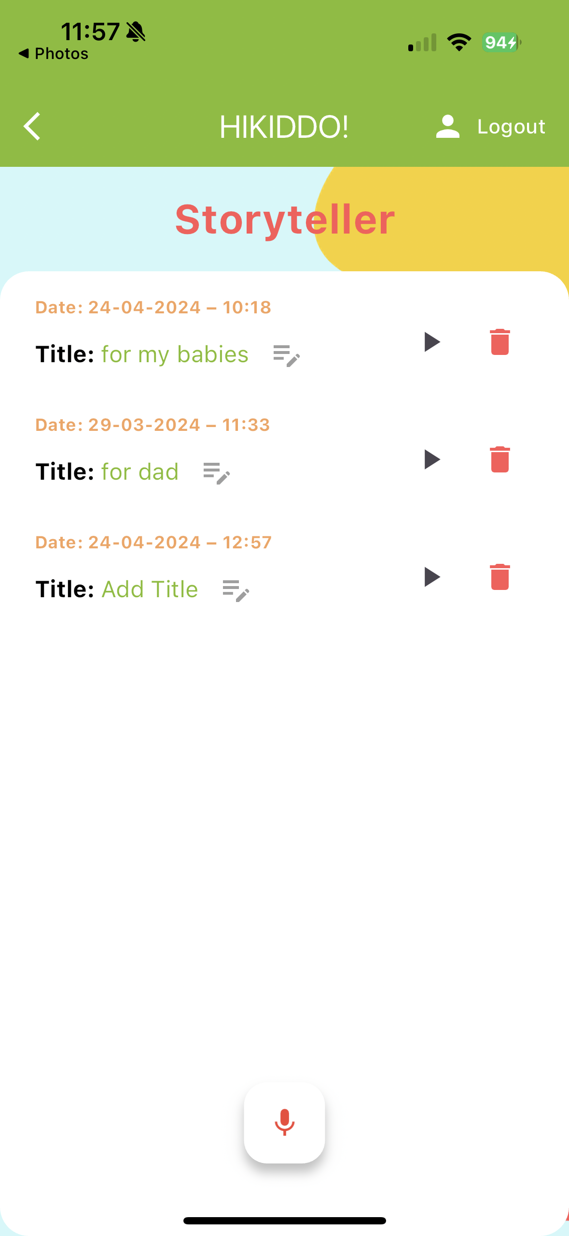

Storyteller: This feature enables users to record meaningful messages for their loved ones or create bedtime stories for children to listen to at night. Every member can contribute by adding a recording and editing its title. Each recording has a play button for easy listening and a delete button for removal. The delete option is available to the host user and the user who made the recording.

Sequence Diagram

The use of a sequence diagram in developing the Hikkido mobile application is crucial. It provides a visual representation of the sequence of operations, interactions between system components, and user actions, facilitating a clearer understanding of the app's functionality and flow.

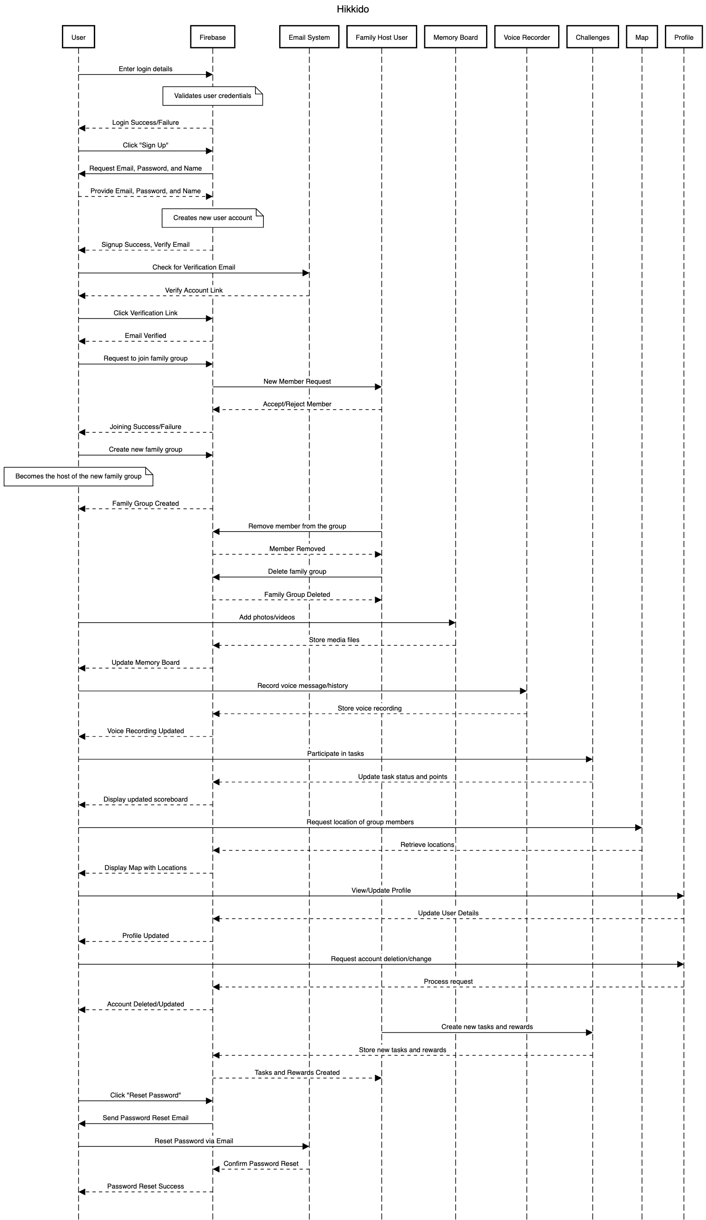

Essential interactions in the Hikkido mobile application include:

* Users log in with their details, which Firebase verifies. New users can sign up with an email, password, and name. They must verify their account via a confirmation link sent via email.
* Users can request to join a family group, which the Family Host User can approve or deny. Users also have the option to create a new family group and become its host.
* Once authenticated, users can engage with app features. They can upload photos and videos to the Memory Board, record voice messages, participate in challenges completing the task created by the host user, and see group members' locations displayed on the map.
* Users can view and edit their profiles or delete their accounts. Additionally, if users forget their password, they can reset it via a link sent to their email.

# 6. Tools and implementation

## 6.1 Tools

*300 words*

*Describe the tools (programming environments & languages, frameworks, and libraries,) you used for the development of your application. Justify your choices with references to your use cases or list of requirements.*

*State existing skills development and any new skills you employed for building your project*.

To develop the "HiKiddo" app, I ventured into new technological territories as I was predominantly familiar with Kotlin and iOS development from my previous mobile programming modules. Through the research for the development of this project I was introduced to Flutter and Firebase, technologies that were new to me but essential for achieving the desired functionality and user experience of the app.

Tools and Technologies Used:

Flutter & Dart

Flutter, powered by the Dart language, was chosen as the primary framework for developing "HiKiddo". It allowed for the creation of a visually attractive and responsive user interface for both Android and iOS platforms from a single codebase. Dart's syntax and functional programming aspects intrigue me as opportunities to step out of my comfort zone and immerse myself in learning a new language and framework.

Firebase

Firebase was utilised as the backend for the "HiKiddo" app, offering key services, including authentication (firebase_auth), database management (cloud_firestore), and file storage (firebase_storage). This integration is particularly beneficial as Firebase pairs seamlessly with Flutter, streamlining the development process. It facilitates real-time data synchronisation, critical for the app's features and regular updates. Additionally, Firebase’s authentication module boosts security by effectively managing user sessions.

Comparative Overview and Strategic Decisions

The decision to pair Firebase with Flutter for the "HiKiddo" app was driven by several considerations:

Unified Codebase: Flutter’s ability to let developers build apps for both iOS and Android from a single codebase combines well with Firebase’s versatile backend services.

Real-Time Interaction: Both platforms work well towards supporting dynamic interactions essential for the real-time functionality seen in "HiKiddo".

Scalability and Ease of Use: The scalability of Firebase and the straightforward UI capabilities of Flutter combine, creates a powerful and user-friendly development environment, perfect for building "HiKiddo".

Google Maps Platform

Google Maps API, known for its extensive mapping capabilities, was integrated into the app to enhance location-based features, allowing users to view each other's locations in real time.

Dart and Flutter packages used:

*flutter_svg*: A rendering and widget library for Flutter that enables the painting and display of Scalable Vector Graphics. Used to display Google, Apple and Facebook logos.

*location, geolocator*: This is used to access devices' location and geolocation features easily.

*permission_handler*: This plugin provides a cross-platform (iOS, Android) API to request and check permissions.

curved_navigation_bar: To enhance the UI/UX with appealing icons and navigation bars.

*Provider*: Allows widgets to listen to changes in model or data objects and rebuild when those objects change.

*image_picker, firebase_storage*: To upload and store images.

*google_maps_flutter*: To integrate Google Maps into the app.

*file_picker, video_player, video_thumbnail*: For managing media files.

*flutter_sound*: used to handle audio recording and playback operations.

path_provider: This package finds the correct file paths for storing app data on mobile devices.

audioplayers: this package allows for playing audio files from assets, files, or URLs.

*intl*: It provides tools to format dates, numbers, and strings.

General Mobile Development

My background in Kotlin and experience with iOS frameworks provided a strong foundation that helped me quickly understand the basic concepts necessary for mastering new platforms like Flutter and Firebase.

New Skills:

I had to learn both Flutter and Firebase from scratch. For Flutter, I started with the fundamentals, learning Dart programming and how to effectively utilise Flutter widgets by exploring documentation and following detailed tutorials on YouTube. Simultaneously, I worked on gaining expertise in Firebase, which was vital for securely and efficiently managing user authentication and data storage.

I enhanced my user interface design skills by using Flutter libraries like *curved_navigation_bar* and *flutter_spinkit*, which improved the app's visual appeal and functionality. I also learned to integrate comprehensive mapping and location tracking features using the Google Maps API and managing location data with geolocator effectively. Additionally, I developed skills in multimedia management by utilising tools such as Flutter’s video_player and flutter_sound, allowing for the inclusion of voice recording and video recording features that enriched the user experience in the "HiKiddo" app.

## 6.2 Implementation

2500 words

Explain implementation of main code by use case. Include pseudocode or snippets of any novel code. Highlight any code that is adopted/adapted and give the original sources. Make references to your design documentation where appropriate.

# 7. Testing

*Create sufficient test cases to determine that the applications satisfy the requirements and works correctly*.

## 7.1 Test coverage

*800 words*

*Discuss black box and/or white box testing against the requirements. Include specific test cases labelled by the relevant requirements*.

In the development of any software, it is crucial that we ensure that an application aligns with its intended requirements. Two key testing methodologies used in this process are Black Box Testing and White Box Testing, each offering unique advantages. Exploring both methods provides insight into how they contribute to confirming that the software performs as expected and helps pinpoint potential improvements.

Black Box Testing:

Black Box Testing checks the software from the outside without looking behind the scenes. Using this methodology, we can see how the application responds to inputs, focusing on ensuring it works well, is easy to use, and performs efficiently from a user's perspective.

White Box Testing:

White Box Testing, on the other hand, is based on testing internal structures, workings, and logic of the application code. It is more concerned with how the system executes a particular function, the pathways through the code, and the handling of data inputs and outputs.

Discussion:

Black Box Testing is essential for validating user experience and ensuring that the application behaves as expected from an external viewpoint. It emphasizes the functionality that the end-users will interact with, and it is not concerned with the internal coding practices. This form of testing is ideal for detecting unanticipated errors in the user interface and user interaction flows.

In contrast, White Box Testing is integral for ensuring the quality of the code and the logical pathways inside the application. It allows for a thorough examination of the codebase, which helps in identifying logical errors, security flaws, and areas where the code could be optimized or refactored for better performance.

Both Black Box and White Box Testing are necessary for a comprehensive quality assurance process. While Black Box Testing might reveal a functional discrepancy, White Box Testing might pinpoint the exact block of code responsible for the issue. By implementing both methods in tandem, developers and testers can ensure that both the visible functionalities and the underlying codebase align with the requirements of the application.

Conclusion:

The juxtaposition of Black Box and White Box Testing against application requirements forms the bedrock of a robust testing strategy. Black Box Testing ensures that the application's interface and interactions meet the users' expectations and the specified requirements. White Box Testing, by diving deep into the code, guarantees that the underlying logic and structure stand up to the rigorous standards of modern software development. Employing both methods in harmony ensures a well-rounded approach to verifying that the Hikkido mobile application is reliable, secure, and user-friendly, meeting all specified requirements with finesse.

## 7.2 Test methodology

*800 words*

*Describe how the output was tested and why. Discuss how you obtained and used feedback, using expert or/and non-expert users*.

# 8. Conclusions and reflections

*1000 words*

*Provide critical reflections on ALL aspects of the project lifecycle. Include conclusions on the resulting application, research, and findings. Reflect on each aspect of your project life cycle. Critically evaluate how effectively your results meet your stated objectives. Reflect on strengths and weaknesses of your implementation, discuss the acquisition of any new knowledge and skills and consider further work*.

# 9. References

*Include a list of cited in your text items (books, papers, websites, etc.). Use Harvard style for the purpose, or any other preferred standard referencing style*.

# 10. Bibliography

*Include here a list of general reading items (books, papers, websites, etc.). List the items in alphabetical order, using Harvard style to describe them*.

# Appendix I

*Provide additional material, if appropriate, in separate appendices.*

*Use one Appendix to provide a link to an on-line video demo of the project.*

*Do not include the entire code in print as an appendix.*